
ITAP 3: DEVELOPING DIAGNOSTIC ASSESSMENT
PGCE Secondary ITAP
Leeds Trinity University | 2025-2026 | PGCE Secondary

Why am I doing this ITAP?
All trainee teachers are required to complete 20 days of ITAP during their courses. This ITAP represents 2.5 days of ITAP time, spread across a range of school and university-based activities. This ITAP is designed to develop your knowledge and understanding of Diagnostic Assessment within your subject area.
During this ITAP you will learn more about how teachers gauge pupils’ learning before, during and after teaching input. You will be equipped with a range of strategies to employ both within lessons and across sequences of lessons. You will plan, teach, and evaluate your own learning episode with a focus on diagnostic assessment. In doing this you will:
- Read key generic and subject literature and observe expert colleagues.
- Develop specific pedagogical approaches for assessing learning within a lesson in your subject through your SKAP sessions.
- Work closely with your Mentor to reflect on how they use Diagnostic Assessment and how this might inform your own practice.
- Plan and deliver a learning episode, observe the impact of your teaching, and evaluate your approach individually, with your Mentor, and with peers.
This process is one which you will engage in again and again throughout the course. As well as helping you develop as a teacher, it also helps you develop the skills to secure key Competencies, particularly in the domains of teaching and assessment.

What exactly is diagnostic assessment?
Diagnostic assessment refers to the ways in which teachers identify what- and how well- pupils are learning within lessons.
- It helps teachers gain an awareness of how much pupils have understood and of any knowledge-gaps which might need to be filled.
- It enables teachers to evaluate their own effectiveness as well as develop an awareness of where the need for adaptation lies.
- It empowers teachers to explore pupils’ prior knowledge; the impact and cognitive demands of tasks, the effectiveness of task or lesson sequencing and much more (Bruner, 1960; Vygotsky, 1962; Piaget, 1971; Sweller, 1988; Sweller et al., 2019).
- It is the starting point which enables teachers to meet the needs of their pupils. You will focus on how teachers can respond to assessment and adapt their teaching in ITAP 5.
Each subject will have its own approaches for diagnostic assessment. This might be seen through questioning, exit tickets or review of learning in pupils’ exercise books. This ITAP will help you to reflect on the practices you are seeing in school and link this to key research literature around the topic in order that your planning and teaching might keep Diagnostic Assessment as a key focus.

When do I complete this ITAP?
This ITAP is completed towards the end of your Stage 1 School Experience. You can see when the ITAP sessions will happen on the outline plan below.
Week | Mon | Tue | Wed | Thu | Fri
11 | School Experience | School Experience | School Experience | School Experience | SKAP ITAP
12 | School Experience (inc. ITAP) | School Experience (inc. ITAP) | School Experience (inc. ITAP) | School Experience (inc. ITAP) | SKAP
13 | School Experience (inc. ITAP) | School Experience (inc. ITAP) | School Experience (inc. ITAP) | School Experience (inc. ITAP) | SKAP ITAP

How do I complete this ITAP?
The Diagnostic Assessment ITAP is completed across school and university. It is divided into three interconnected steps. Each step includes a number of key tasks. There is space in this booklet for you to record relevant reflections and notes.
Timing | Step | Location
Friday Week 11 | - SKAP ITAP: Understanding diagnostic assessment.  - Exploring the role of assessment in teaching.  - Reflecting on school experiences of assessment.  - Developing a Diagnostic Assessment toolkit.  - Planning to implement diagnostic assessment. | University  1 day
Monday Week 12 to Thursday Week 13 | - School-based ITAP: Diagnostic assessment in action.  - Observing Diagnostic Assessment in context.  - Discussion with the Mentor / Host Teacher.  - Teaching and reviewing a lesson. | School  1 day equiv. across two weeks
Friday Week 13 | - SKAP ITAP:  - Reviewing the impact of adaptive teaching approaches.  - Reflection and key learning points | University  0.5 day

What is the underpinning research?
Our underlying model for the PGCE is that Trainees learn in and across many overlapping contexts. This is not a simple, linear process. Our whole course is informed by Clarke and Hollinsworth’s ‘Change Environment’ model (2002), which suggests that learning needs to happen through the interplay of multiple domains.
- The Personal Domain – our own beliefs and ideas, as well as what we know and how we make sense of new approaches, strategies and perspectives.
- The External Domain – learning about new approaches, strategies and perspectives from reading, professional discussion, direct input etc.
- The Practice Domain – trying out new approaches, strategies and perspectives in the classroom.
- The Consequence Domain – seeing the results of actions and drawing conclusions on the back of these.
This ITAP has been designed to draw on all four of these domains to promote lasting change in ideas, actions and beliefs about teaching.

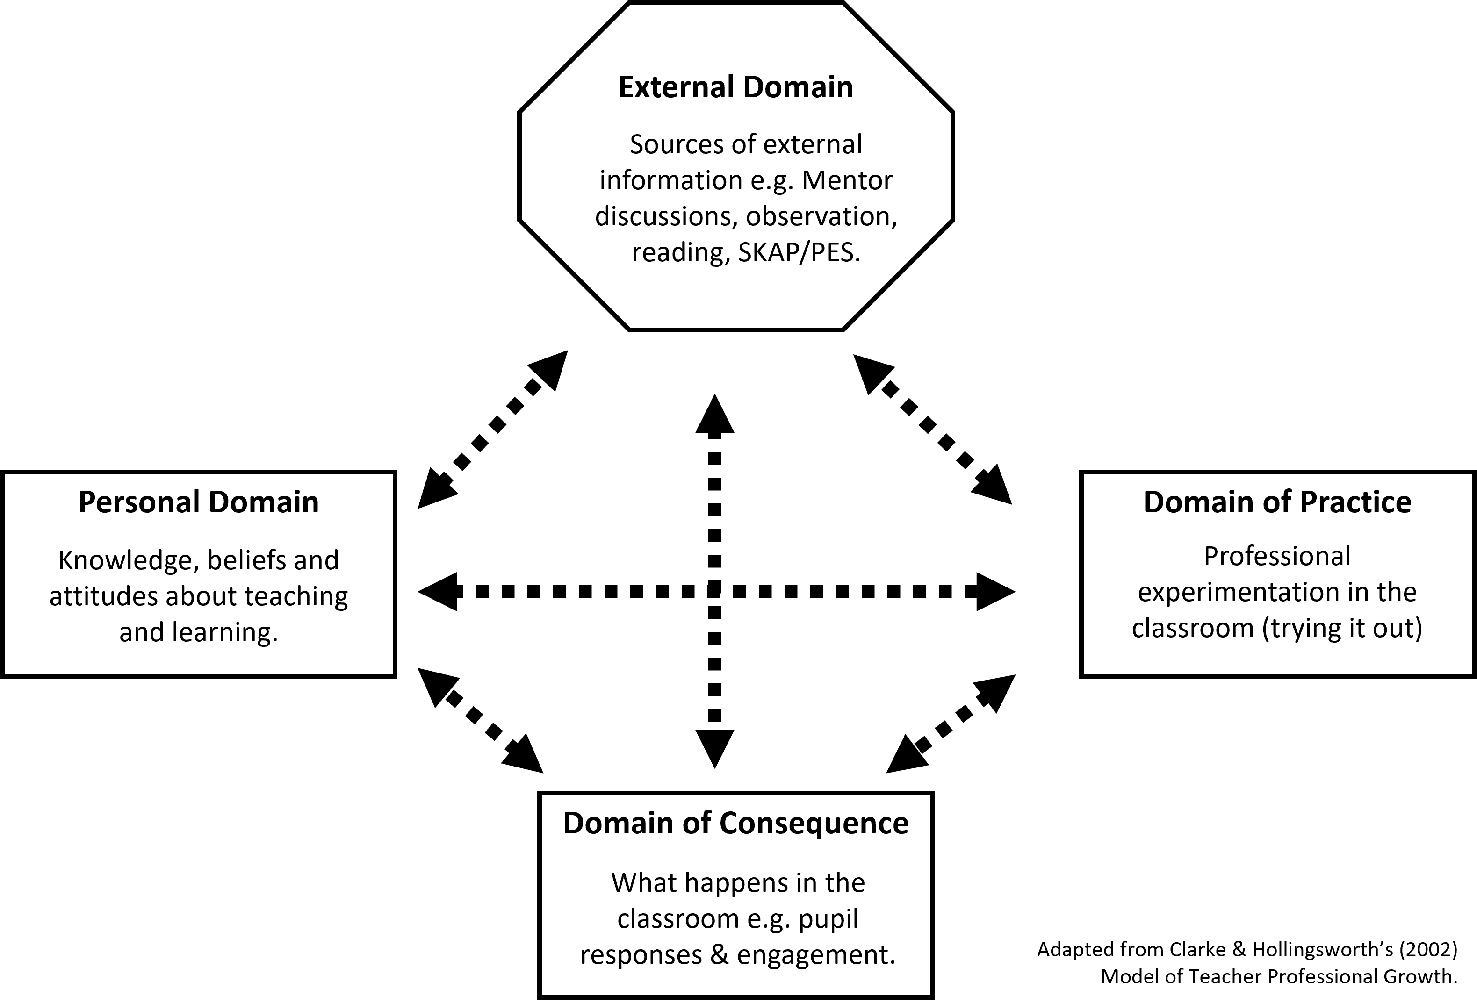

Step 1: SKAP ITAP session – Understanding Diagnostic Assessment (Week 11)

1a. Exploring the role of assessment in teaching
To develop your understanding of diagnostic assessment, so that you might implement it within your own practice, you need to make connections between key research literature and what happens in school. The required reading is outlined below.
- Fletcher-Wood, H. (2018). Responsive teaching: cognitive science and formative assessment in practice. Routledge. Chapter 4: pp.58-75
- Speckesser, S., Runge, J., Foliano, F., Bursnall, M., Hudson, N., Rolfe, H., & Anders, J. (2018). Embedding Formative Assessment: Evaluation Report. EEF. https://dera.ioe.ac.uk/id/eprint/32012/1/EFA_evaluation_report.pdf (esp. pp 4-5 & 41-42)
Summary of key takeaways from reading

1b. Reflections from school experience
In this phase of the ITAP you need to reflect on what you have seen in practice during your School Experience. Please read and respond to the questions below to inform discussion during your SKAP session.
Task 1: Think back to some of the in-class assessments you have seen in school or examples from your own practice throughout Stage 1.
How do teachers establish what pupils already know as they begin to teach? How do the results of these checks affect what they do in the classroom?

How and when do teachers check on pupils’ learning and progress after the start of the lesson?
How do teachers monitor ongoing progress across a series of lessons? How does this impact on their practice in future lessons?

1c. Diagnostic Assessment Toolkit
As a group, summarise the Diagnostic Assessment strategies that will work well for your subject.


1d. Planning to Implement Diagnostic Assessment
Choose a lesson that you will plan and teach, focusing on the diagnostic assessment. Write down the group and lesson focus here.

What do you want to find out with your diagnostic assessment(s)?  Note down key things you want to identify e.g. what they already know, how well they understand the concepts being taught and whether they have misconceptions. | Which Diagnostic Assessment strategies from the toolkit do you think you will use? How will you use them?  Consider the specific things you want to check or find out. Which approaches would best help with this? Be specific e.g. focus on specific questions you could ask. | What do your peers think of your choice of strategies?  Ask a peer to comment on your strategy choices. Will your Diagnostic Assessment ideas help you find out what you want to know?

Step 2: School based ITAP – Diagnostic assessment in action (Week 12-13)
During Step 2 you will further explore how Diagnostic Assessment is being used, before planning and implementing your own strategies for Diagnostic Assessment with a chosen group. You will also reflect on how well these approaches worked.

2a. Observing Diagnostic Assessment in Context
Arrange to observe your Mentor / Host Teacher. Ensure you speak to them beforehand to seek permission to observe. You should also show them this proforma so they can see what you are looking for. This is both a professional courtesy and will enable you to have more fruitful discussions after the lesson.
Note the class, topic and objectives of the lesson.
How did the teacher monitor pupils’ learning? | What do you think it told them? | How did the teacher respond to what they found out?

2b. Discussion with mentor / host teacher
Ask your Mentor / Host Teacher to explain why they chose to use the Diagnostic Assessment strategies they did. Summarise the strategy, what they found out and how they will use this information below.
Talk about your own lesson plan (to be taught during weeks 12 or 13) and explain to the Mentor /Host Teacher the plans you have to implement Diagnostic Assessment opportunities in the lesson. Explain what you are hoping to find out and how each assessment will work.
Note any key points or changes you are going to make following this discussion.

2c. Teach your planned lesson.
You now need to teach the lesson you have planned, focusing on the Diagnostic Assessment strategies. Remember to look carefully at how pupils respond to your strategies.

2d. Review evidence of learning from the taught lesson
Now you have taught the lesson, you need to review the evidence of the impact of your Diagnostic Assessment strategies. To do this you will need to think carefully about what happened in the lesson when you used your strategies. This might mean looking at pupils’ books, reviewing materials created during the lesson, or just reflecting on how pupils acted or responded to prompts.
What evidence did you choose to explore/think back on?
Does the evidence suggest that pupils learned what you had wanted them to learn? Which Diagnostic Assessment strategies helped you see this?
Did any common misconceptions or errors emerge within the lessons? Which Diagnostic Assessment strategies helped you see this? How might you avoid or address these misconceptions in future?

2e. Sharing Your Reflections
Finally, you should share the results of your review with your Mentor via the Development Record. You will also need to be ready to speak to your peers about your experiences with Diagnostic Assessment in Step 3.
Make sure you reflect on the progress of this group in your Development Record for this week.

Step 3: SKAP ITAP session – Sharing and reflecting (Week 13)
In this SKAP ITAP session, you will be sharing the results of your experiments with diagnostic assessment.

3a. Presentation
During the SKAP ITAP session, you will present to your peers and Subject Tutor about your experiments with diagnostic assessment.

You will need to:
- Summarise your lesson and the Diagnostic Assessment strategies you used.
- Reflect on what happened during delivery and any feedback you were given.
- Share an issue you faced during delivery or a question you still have about diagnostic assessment.

3b. Peer Reflections
This is a space for you to gather feedback you have received from your peers.

3c. Reflecting on Your Learning
Reflect on how your thinking has changed over the course of this ITAP. Use the Clarke and Hollingsworth (2002) model (from the beginning of the booklet) to explain how your ideas about Diagnostic Assessment have developed and changed.

References

Bruner, J. S. (1960). On learning mathematics. The Mathematics Teacher, 53(8), 610-619.
Clarke, D., & Hollingsworth, H. (2002). Elaborating a model of teacher professional growth. Teaching and zteacher education, 18(8), 947-967.
Fletcher-Wood, H. (2018). Responsive teaching: cognitive science and formative assessment in practice. Routledge. Chapter 4: pp.58-75
Piaget, J. (1971). The theory of stages in cognitive development. In D. R. Green, M. P. Ford, & G. B. Flamer, Measurement and Piaget. McGraw-Hill.
Speckesser, S., Runge, J., Foliano, F., Bursnall, M., Hudson, N., Rolfe, H., & Anders, J. (2018). Embedding Formative Assessment: Evaluation Report. EEF. https://dera.ioe.ac.uk/id/eprint/32012/1/EFA_evaluation_report.pdf
Sweller, J. (1988). Cognitive load during problem solving: Effects on learning. Cognitive science, 12(2), 257-285.
Sweller, J., van Merriënboer, J. J., & Paas, F. (2019). Cognitive architecture and instructional design: 20 years later. Educational psychology review, 31, 261-292.
Vygotsky, L. S. (1962). Thought and language. Cambridge, MA: MIT Press.

