
ITAP 1: PLANNING LESSONS AND LEARNING ACTIVITIES
PGCE Secondary ITAP
Leeds Trinity University | 2025-2026 | PGCE Secondary

Why am I doing this ITAP?
All trainee teachers are required to complete 20 days of ITAP during their programmes. This ITAP represents 5.5 days of ITAP time. This ITAP is designed to develop your knowledge and understanding of how teachers plan lessons and activities in your subject area.
During this ITAP you will learn more about the fundamentals of effective planning and the considerations teachers have when planning for learning in your subject area. You will then write your own lesson plan based on this learning. In doing this, you will:
- Read subject literature, observe lesson episodes on placement, and receive expert input on effective planning.
- Work with peers to develop a critical understanding of how planning works in your subject area.
- Plan your own lesson and share this with your Subject Tutor and your peers.

When do I complete this ITAP?
This ITAP is completed as you begin your Stage 1 School Experience. It will help you develop the skills to secure the key Competencies needed for the Stage. You can see when the ITAP sessions will happen on the outline plan below.
Week | Mon | Tue | Wed | Thu | Fri
2 | PES ITAP | SKAP ITAP |  | PES ITAP | SKAP ITAP
3 | PES | PES | SBT (inc. ITAP) | SBT (inc. ITAP) | SKAP
4 | SBT (inc. ITAP) | PES | SBT (inc. ITAP) | SBT (inc. ITAP) | SKAP ITAP

How do I complete this ITAP?
This ITAP is divided into six interconnected steps. Each step includes a number of key tasks. There is space in this booklet for you to record relevant reflections and notes. Tasks might include:
- Consolidating or reflecting on taught sessions
- Completing reading or other research
- Having professional discussions
- Planning or delivering teaching
- Receiving and responding to feedback

Timing | Step | Location
Monday Week 2 | - PES ITAP: What are the fundamentals of classroom practice?  - What do I need to know about the brain and learning?  - What are the core principles of planning for learning? | University  1 day
Tuesday Week 2 | - SKAP ITAP: What do pupils need to know about my subject?  - What should all pupils understand about my subject? How does my subject work? What are the core ideas / types of knowledge?  - How are pupils taught my subject? What is the curriculum in my subject and how does it relate to planning and how pupils develop over time? | University  1 day
Thursday Week 2 | - PES ITAP: The pedagogies of effective learning.  - How do teachers know pupils are learning?  - How can teachers ask good questions? | University  1 day
Friday Week 2 | - SKAP ITAP: How do I plan for learning in my subject?  - How can subject specific knowledge and concepts be embedded effectively?  - What do effective learning activities look like in my subject?  - What does effective lesson planning look like in my subject? | University  1 day
Wednesday Week 3 to Thursday Week 4 | - School Experience ITAP: Planning a lesson in my subject area.  - At this point, you do not need to teach this lesson. | School  1 day equiv. across two weeks
Friday Week 4 | - SKAP ITAP: Reviewing and amending lesson planning.  - Peer review of lesson planning.  - Consideration of amendments and improvements to lesson plans.  - Submission of the ITAP booklet. | University  0.5 days

What is the underpinning research?
Our underlying model for the PGCE is that Trainees learn in and across many overlapping contexts. This is not a simple, linear process. Our programme is informed by Clarke and Hollinsworth’s ‘Change Environment’ model (2002), which suggests that learning needs to happen through the interplay of multiple domains.
- The Personal Domain – our own beliefs and ideas, as well as what we know and how we make sense of new approaches, strategies and perspectives
- The External Domain – learning about new approaches, strategies and perspectives from reading, professional discussion, direct input etc.
- The Practice Domain – trying out new approaches, strategies and perspectives in the classroom.
- The Consequence Domain – seeing the results of actions and drawing conclusions as a result
ITAP 1 has been designed to enable you to draw on the personal domain and supplement this with input from the external domain (reading, discussion, and tutor input). This aims to give you a good base of knowledge to bring into your School Experience where the final elements of the change environment come into play: experimenting in the classroom and observing the impacts.

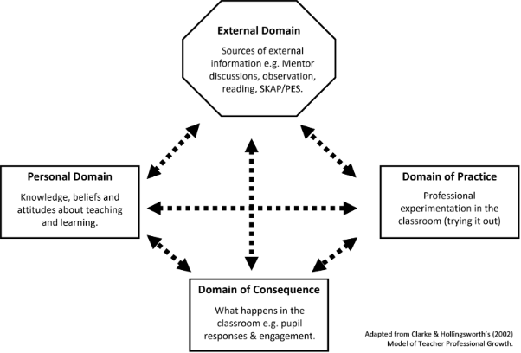

Step 1: PES ITAP session - What are the fundamentals of classroom practice? (Week 2)
In this part of the ITAP you will take part in lectures and workshops at university which focus on the fundamentals of classroom practice. The core ideas from these sessions will underpin your developing knowledge of how teachers plan effective lessons and activities both in general, and in your subject. These PES ITAP sessions draw directly on key aspects of the Initial Teacher Training Early Career Teacher Core Content Framework (ITTECF) and will help you in developing your understanding of planning for the Competencies.
During this PES ITAP session you will address the following questions:
- What do I need to know about the brain and learning?
- What are the core principles of planning for learning?

For each session complete the related activities in this booklet. These activities will help you process these sessions and demonstrate your developing thinking across the ITAP and into your practice.

1a. What do I need to know about the brain and learning?
In this session you will explore recent research around the importance of memory in the learning process. You will look at how learning can be enhanced when cognitive load and memory are considered during planning and teaching. You will also look at the limits of cognitive theories, especially in relation to pupils who are not neurotypical. This will underpin work you do around planning and teaching in SKAP.
Summary of ‘the learning brain’. Double click the boxes to add text
F
…
R
E
C
__________________ Memory
Definition…
__________________ Memory
Definition…
Sensory memory is…

Summarise your understanding of cognitive load.
What have you learnt about different strategies to support memory retention?
Why is it important to know about cognitive load as a teacher?

1b. Consolidating Understanding
Read ITAP 1 - Rosenshine (2012) Principles of Instruction Article.pdf then answer the questions below
List Rosenshine’s ‘Principles of Instruction’ | 1.  2.  3.  4.  5.  6.  7.  8.  9.  10.
Which ones of these do you feel most confident to incorporate into a lesson?
Which one might you find more challenging to incorporate into a lesson? Why?

1c. What are the core principles of planning for learning?
In this workshop, you will begin to consider the building blocks of effective lesson planning, identifying how these are grounded in both short and medium term objectives.
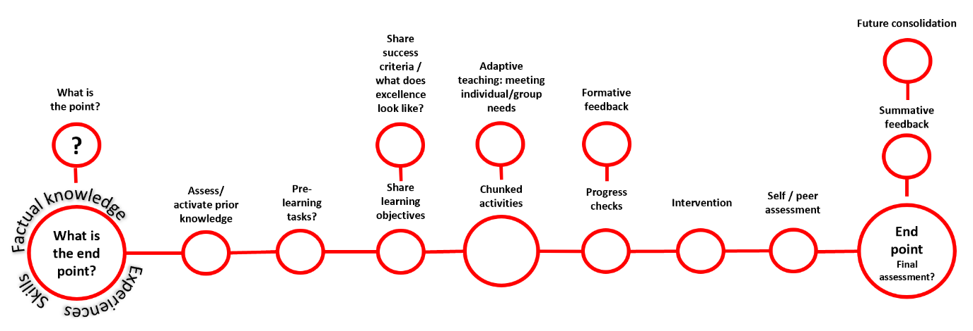
Reflect on the PES session “What are the core principles of planning for learning?”
Summarise your understanding of each planning principle from the diagram above.
Planning principle | Brief summary of this planning principle
What is the end point? / What is the point?
Pre-learning tasks

Sharing objectives / success criteria
Chunked activities

Meeting individual needs (Adaptations/ SEND)
Progress checks & formative feedback
Intervention

Self / peer assessment
Final assessment / feedback

Step 2: SKAP ITAP session – What do pupils need to know about my subject? (Week 2)
During this SKAP ITAP session you will:
- Share the key points you wrote in Step 1
- Consider how pupils experience your subject in terms of its core knowledge and practices
- Examine the curriculum in your subject and how it relates to planning

2a. What should all pupils understand about my subject?
Use this space to record your key takeaways from the SKAP session. You might have covered issues such as: how your subject works; core ideas in your subject; types of knowledge.

2b. How are pupils taught my subject?
Use this space to reflect on your key takeaways about the curriculum in your subject, how it relates to planning, and the ways in which pupils are expected to progress over time.

2c. Reflections on step 1 and 2.
Reflect on the content of the PES and ITAP sessions and discuss the implications and applications for planning in your subject.

Step 3: PES ITAP session - The pedagogies of effective learning (Week 2)
During this PES ITAP session you will address the following questions:
- How do I know my pupils are learning?
- How do teachers ask good questions?

3a. How do I know my pupils are learning?
This session unpicks the role of formative assessment in the classroom and considers how it enables teachers to establish ;-
- pupils’ prior knowledge
- identify misconceptions
- ensure learning is being embedded in memory
It will explore a variety of methods for checking on learning and evaluate their potential benefits and drawbacks.
What are my takeaways about formative assessment and how can I use it in my planning to address the bullet points above?

3b. Reading
Read ITAP 1 - Black et al (2004) Working Inside the Black Box - Article.pdf . Use it to respond to the questions below.
How would you define Assessment for Learning? Try to do this in no more than 2 sentences (p.10)

How did teachers’ questioning practice change when they began to use AfL techniques in their questioning? (p.11-13)
Pick three key messages about how to do effective Assessment for Learning (p.13-16)
What notes of caution do the researchers offer? (p.16-18)
Note down two questions you have about AfL from the remainder of the article (p.18-21)

3c. How do teachers ask good questions?
This session will allow you to explore when, how and why teachers ask questions in the classroom. It will explore the different types of questions teachers use for various purposes as well as how these might be adapted for different groups or learners. It will also cover some broad techniques for effective questioning as well as common pitfalls to avoid. Complete the table with some subject specific examples.
Type of question | Give an example in your subject | What’s the purpose of your question?
Closed
Open
Hinge/
Diagnostic
Recall

List some strategies that you can use to engage all pupils when you are questioning them.

3d. Reflections on Step 3
Now that you have completed your initial sessions, you should note 2 or more key questions you have about planning which you would like to explore further in SKAP.

Step 4: SKAP ITAP session – How do I plan for learning in my subject? (Week 2)
This is your final section of formal input before you begin writing your own lesson plan. During this SKAP ITAP session you will take part in a range of activities which will enable you to explore:

  - How subject specific knowledge and concepts can be embedded effectively
  - What effective learning activities look like in your subject
  - What effective lesson planning looks like in your subject

4a. How do pupils learn in my subject and how do we embed knowledge effectively in lessons?
Key takeaways about how pupils learn in your subject and how knowledge is embedded.

4b. What does effective planning look like in my subject?
Key takeaways about effective planning in your subject and using the lesson plan proforma.

Full Lesson Planning Proforma

Trainee |  | School / Dept
Lesson Topic |  | Date of Lesson |  | Class / Group

Learning Context | What prior learning has happened? How does this lesson fit into the bigger scheme?
Aims for learning | Objectives: What specific knowledge, concepts and/or skills do you want pupils to learn, develop or improve? | Outcomes: What will you see? What will pupils have done by the end of the lesson? Check these connect with your lesson objectives.
Misconceptions | Research any misconceptions which may arise. How will you address these?
Adaptive and inclusive teaching | How will you provide challenge and support for the specific needs in this group?
Homework | Homework to consolidate or extend learning (if relevant)
Classroom environment | Role of other staff members / health and safety issues

Element | Time | What is the learning focus?  What will pupils be learning – linked to Learning Objectives. | What will be happening in the classroom?  Outline specific actions you need to take as a teacher as well as what pupils will be doing. | How will I check they are learning?  How will you know / monitor they have all grasped this? | Resources / Environment / Classroom Management
Start of Lesson Routine
Introduction
Development

Sub-divide as needed.
Conclusion / Plenary / Review

Lesson evaluation: How did the lesson go? Were your objectives met? Did your activities work as expected? Why? Why not?

Step 5: School Experience ITAP - Planning a lesson in your subject area (Week 3-4)
During this step of the ITAP you need to plan your own lesson using the guidance you have received in steps 1-4.

5a. Planning your lesson
During your school-based time in Weeks 3 and 4, you will need to plan your subject specific lesson. Remember, you don’t need to actually teach this lesson; we are more interested in embedding the ideas around effective planning at this point.

You must discuss this step with your mentor in order to get feedback on your strengths and development opportunities.

You will need to share the lesson you plan in your next SKAP ITAP session.

In order to do this, you will need to speak to your Mentor to ensure you have opportunities to do all of the following things:
- Consider examples of planning in your subject area across both Key Stages for which you are training.
- Reflect on these lesson plans in light of your reading and research.
- Identify a group and a topic area for which to produce your lesson plan.
- Draft a lesson plan and speak to your Mentor about it.
- Finalise your lesson plan and any related resources.
You might want to include additional examples of any resources you are using with this plan. For example, this may be a worksheet you have designed but we do not want to see a PowerPoint.
One of the key aims when planning a lesson is to ensure it is clear enough that:
- Your Mentor can understand what you are trying to achieve and how you are going to do it.
- Your plan is clear enough that another teacher could pick it up and have a good idea what you are attempting to do.
You will find the planning proforma on the previous page. There is a lesson planning prompt sheet in Step 6 which you might find helpful.

5b. Reflections on Step 5
Now you have completed your initial sessions, you should note 3-4 key points you want to bring to the SKAP ITAP session (Step 6). This could be:
- Things you found tricky
- Key decisions you made
- Questions you are still thinking about
- Create a target in your development record (week 4) with your mentor on lesson planning
Note your reflections on your planning and summarise the conversations with your mentor including the target set.

Step 6: SKAP ITAP session – Peer Review of planning (Week 4)
During the SKAP ITAP session you will present your lesson plan and the ideas behind it to your peers.

6a. Discussion about the planning process
Think back to your notes from Step 5b. Work in pairs or small groups to address the following discussion points in turn:
- What is your lesson about? Outline your lesson plan (and any resources) and its aims. What pupil misconceptions might arise in teaching this lesson?
- What key decisions did you make when producing this plan? What feedback did you get along the way?
- What issues did you face during the planning process?
- What questions do you still have about planning?

6b. Peer reflections on use of proforma
Ask one of your peers to review your lesson plan. The aim is to check the lesson plan would be clear to another teacher if they were asked to deliver it. Ask them to provide comments in your booklet here using the prompt questions below.
(1) Lesson Topic: Is there a clear and precise topic area?
(2) Learning Objectives:
- Are there clear learning objectives?
- Do they run in a logical order so that they build on one another?
- Do they cover knowledge development and application as appropriate?
- Are they written with a clear action and content/skill focus?
- Are they assessable?
(3) Outcomes: Is there a clear sense of what will be seen at the end of the lesson?
- Do the learning outcomes describe what will be observed? e.g. all pupils have a 150 word paragraph explaining X; or all pupils will need to identify three main causes of Y.
- Does each objective have an associated outcome?
(4) Misconceptions: Have misconceptions been considered in relation to the planned progress in the lesson?
- Have common issues pupils might encounter studying this topic been identified? It could be to do with substantive knowledge or conceptual knowledge.

Lesson Action Plan Section
(5) Teaching & Learning Activities: Is it clear is happening in each part of the lesson?
- Could someone else pick up this plan and know what is happening?
- Is WHAT pupils are learning and HOW clear?
- Is it clear what teacher and pupils are doing in each part of the lesson?
- Are different lesson elements easy to see?
- Is it clear where any input is coming from e.g. teacher talk, book work, board etc?
- Are required actions noted e.g. pupils take notes on X; or teacher models an example of question 1 on the board?
- Are timings noted and realistic?
(6) What are Pupils Learning: Is it clear what pupils are learning in each part of the lesson?
- Is the specific content focus evident?
Is there a connection with the Learning Objectives?

(7) Monitoring and Assessment:
- Is it clear WHAT learning is being checked?
- Is it clear HOW work/learning will be checked?

(8) Resources / Environment / Classroom Management:
- Are relevant issues noted?
(9) Conclusion / Plenary / Review: Is it clear how learning will be summarised and celebrated?
- Does the conclusion help draw together the key learning?
- Is there some sense of how links might be made to the next lesson?

6c. Your Reflections
The final step of the ITAP is for you to reflect on how your thinking has changed over the course of this process. Use the Clarke and Hollingsworth (2002) model (from the beginning of the booklet) to explain how your beliefs about planning lessons and activities have developed and changed over the course of the ITAP.

You can either write this as prose or create a version of the Clarke and Hollingsworth (2002) model.

6d. Competencies Review
During this ITAP you have been developing your expertise in planning. You should now assess your confidence in the Curriculum & Subject and Planning & Teaching Domains of the Competencies using a Red / Amber / Green scale.

Curriculum & Subject
 | Foundational competencies for Stage 1 | R | A | G
Demonstrate Appropriate Knowledge of the Curriculum | Understanding is shown of statutory curriculum requirements (e.g., National Curriculum, Early Years Foundation Stage Framework).
Use Accurate Subject Content Knowledge | Predominantly accurate subject knowledge is evident across professional practice (planning, teaching, and assessing).
Utilise Pedagogical Content Knowledge | Planning makes use of relevant pedagogical strategies that are appropriate for the subject being taught.
Meet Stated Curricular Aims | Lesson and sequence planning fits with the intent of the school’s curriculum and planning documents.  Plans and resources are appropriate for subject and age phase

Planning and Teaching
 | Foundational competencies for Stage 1 | R | A | G
Set Appropriate Objectives and Outcomes | Lesson objectives and outcomes are used to structure lessons.  There is an awareness of the knowledge and understanding pupils need to develop in each lesson.
Structure Lessons Appropriately | Knowledge of effective lesson structures is evident in planning.  Tasks connect to the lesson objectives.
Be Clear about Planned Tasks and Activities | Time is given to explaining tasks to pupils.  Efforts are made to check pupils understand tasks being set.
Demonstrate Knowledge of How Pupils Learn | Planning shows awareness of the role of memory in learning, especially the importance of building on prior knowledge and embedding new knowledge through appropriate teacher input or tasks
Explain Key Content, Ideas, Concepts, or Skills | Key ideas or concepts of the lesson are identified on planning.
Identify and Manage Potential Misconceptions | Lessons/sequences are planned with awareness of common barriers or misconceptions about a topic and with reference to pupils’ prior knowledge

Bibliography
Black, P., Harrison, C., Lee, C., Marshall, B., & Wiliam D. (2004) Working inside the Black Box: Assessment for Learning in the classroom. Phi Delta Kappan, 86(1), 8-21
Clarke, D., & Hollingsworth, H. (2002). Elaborating a model of teacher professional growth. Teaching and teacher education, 18(8), 947-967
Rosenshine, B. (2012) Principles of Instruction: Research-Based Strategies That All Teachers Should Know. American Educator, 36(1), 12–39

