

Primary PGCE
Pre-programme Handbook

Primary Post Graduate Certificate in Education (PGCE) with Qualified Teacher Status (QTS)

2026-27

Section 1: Introduction 3
1.1 Our Vision and Values 4
1.2 What will I learn and how will I learn it? 4
1.3 The Structure of the Curriculum 5
1.4 Assessment 6
1.5 Recognising and Valuing Diversity 6
1.6 Race Equity 6
1.7 The policies and frameworks underpinning your programme 7
1.8 Attendance and punctuality 7
1.9 Your Primary PGCE Programme Team 8
Section 2: Programme Overview 9
3.1 PGCE (QTS) Programme Pathways 9
3.2 Indicative PGCE Calendar 10
3.3 Domain Focus 11
Section 3: Fundamental English and Mathematics Skills 12
3.1 What You Will Be Expected to Demonstrate by the End of the Programme 12
Top 5 Ways to Prepare Before the Programme Starts 14
Section 4: Supporting your Mental Health and Wellbeing 15
4.1 Your Personal Support Network 15
4.2 Useful Websites for External Support 15
4.3 Support Available from Leeds Trinity 15
Section 5: Recommended Reading 16

Section 1: Introduction

Welcome to the start of an exciting, rewarding and transformative year.

Whether you are joining us straight from university, returning to study after time away, or embarking on a long-held ambition to become a teacher, we are delighted that you have chosen to begin your teaching journey with Leeds Trinity University.

Teaching is one of the most important professions in society. It is also one of the most challenging, creative, and rewarding. Over the coming year you will develop new knowledge, skills and confidence as you learn to support children to achieve, belong and thrive. There will be moments of celebration, moments of challenge, and probably more cups of tea than you ever imagined possible. Through it all, you will be supported by a dedicated community of university tutors, mentors and partnership schools who are invested in your success.

Our Primary PGCE curriculum has been carefully designed to provide a broad, balanced and ambitious introduction to teaching. We want you to leave the programme not only as a competent and confident early career teacher, but as a reflective professional who is curious, creative and committed to making a difference.

Throughout the programme we will:
- Provide a broad, balanced and challenging introduction to teaching that reflects the realities of contemporary primary and early years practice and responds to the needs of our partnership schools.
- Promote the importance of positive mental health and wellbeing, recognising that looking after yourself is an essential part of looking after others.
- Offer a rich range of experiences that support you in developing secure subject, pedagogical and curriculum knowledge, fully aligned with the Initial Teacher Training and Early Career Framework.
- Encourage professional autonomy, ensuring that your voice is heard and that you play an active role in shaping your professional learning journey.
- Support high standards of academic achievement, helping you make meaningful connections between educational theory and classroom practice.
- Create opportunities for purposeful discussion, debate and collaboration, enabling you to become part of a vibrant professional community.
- Foster courageous creativity, encouraging you to take informed risks, try new approaches and inspire children through engaging and meaningful learning experiences.
- Develop your understanding of the wider political, social, economic and cultural influences that shape education and the lives of the children and communities we serve.

Above all, we want you to enjoy the journey. There will be lessons that go brilliantly, lessons that need rethinking, and days when you leave school convinced that you have the best job in the world. Each experience will help you grow.

We are delighted to welcome you to the Leeds Trinity teacher education community and look forward to supporting you as you take your first steps towards becoming an outstanding teacher.
Good luck, enjoy the adventure, and remember: every great teacher started exactly where you are now.

1.1 Our Vision and Values

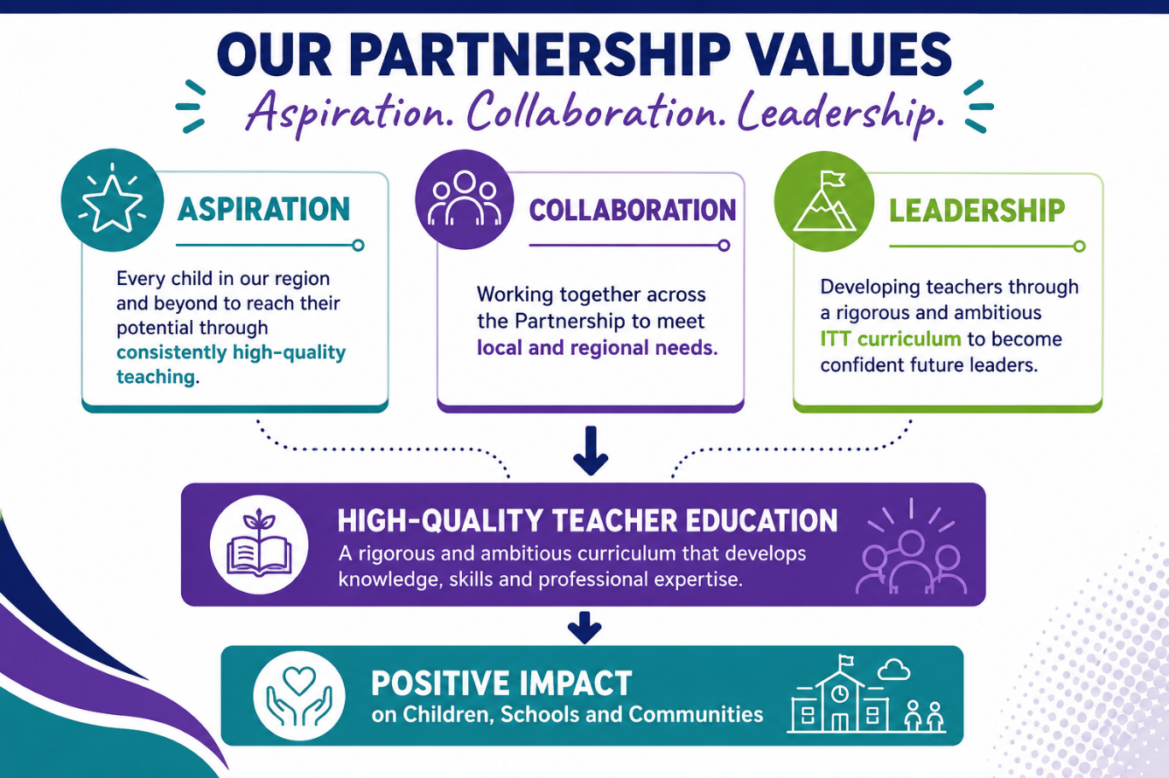

  - What will I learn and how will I learn it?

Your Primary PGCE has been designed to help you develop the knowledge, skills and professional judgement needed to become an effective, reflective and confident teacher. Throughout the year, you will learn about children, learning, teaching and the curriculum. You will explore how children develop and learn, how to create positive and inclusive classroom environments, and how to plan, teach and assess lessons that enable all pupils to succeed. You will also develop secure subject and curriculum knowledge across the primary age range, alongside a strong understanding of adaptive teaching, inclusion, safeguarding and professional responsibilities.

Learning will take place through a carefully sequenced combination of university-based study and school-based practice. This allows you to make meaningful connections between educational theory and classroom experience, continually testing, refining and developing your understanding of effective teaching.

You will learn through:
- Interactive taught sessions that introduce key concepts, research and professional knowledge.
- Workshops and practical activities that allow you to apply and explore teaching approaches in a supportive environment.
- School placements where you will observe experienced teachers, work with children and gradually take increasing responsibility for planning and teaching.
- Coaching and mentoring that provide personalised feedback and support your professional development.
- Intensive Training and Practice (ITaP) cycles that focus on specific aspects of teaching, helping you to practise, reflect and improve.
- Professional dialogue and collaboration with peers, tutors and mentors, enabling you to learn from different perspectives and experiences.
- Independent study and academic assignments that encourage you to engage critically with educational research and connect theory to practice.
- Reflection and self-evaluation that help you identify strengths, celebrate progress and plan next steps in your development.

As the year progresses, you will move from observing and learning about teaching to becoming increasingly confident in leading learning yourself. By the end of the programme, you will have developed the knowledge, understanding and professional habits needed to meet the Teachers' Standards and begin your career as an Early Career Teacher. Most importantly, you will learn that teaching is not simply about delivering lessons. It is about building relationships, inspiring curiosity, supporting children to overcome challenges and helping every pupil to flourish. Throughout the programme, we will support you to develop not only as a teacher, but as a thoughtful and compassionate professional who can make a positive difference to the lives of children and young people.

1.3 The Structure of the Curriculum

The curriculum is developmental, providing you with relevant opportunities and experiences to develop the knowledge, skills and understanding across both school and centre-based training. The programme is divided into three broad phases that align to terms (or university semesters) as outlined below.

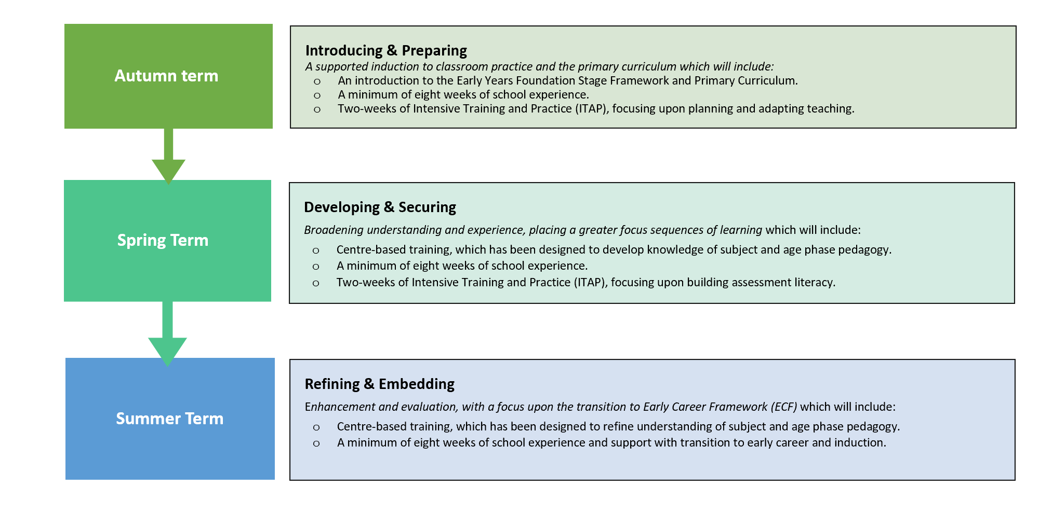
Your curriculum is built on a simple idea: learning happens with you, not to you. This means you are not here to sit back, nod politely and hope teaching somehow happens by magic. You are part of the process. We want you to be prepared, present and curious across all aspects of the programme.

- Centre-based learning will include a blend of lectures, seminars and practical workshops. These sessions are designed to get you thinking, questioning, discussing and trying things out. Collaboration, dialogue and debate are central to high-quality professional learning, so you should expect to talk, listen, reflect, disagree thoughtfully and learn from the experiences of others.
- Continuous Professional Development (CPD) gives you the opportunity to put your developing knowledge and skills into practice. During School Experience, you will have dedicated CPD time where you will be asked to observe, teach, reflect and refine your practice with the support of mentors and expert colleagues. CPD tasks are designed to help you think deeply about the training curriculum, connect ideas to real classrooms and set meaningful targets for your professional development.

In short, you will learn by reading, thinking, talking, watching, doing, reflecting, sometimes getting things wrong, trying again, and gradually becoming the teacher you are working towards becoming.

1.4 Assessment

Assessment on the programme is designed to help you understand how you are progressing and what you need to do next. It is not about catching you out. It is about helping you grow, notice your strengths, identify your next steps and build confidence as a developing teacher.

Your progress will be assessed in a range of ways, including:
- assessments in your academic modules;
- formative feedback during centre-based taught sessions;
- formal and informal observations of your school-based practice;
- verbal and written feedback from mentors and tutors;
- weekly mentor meetings in school;
- your own self-reflection and responses to School Experience Tasks;
- Final Assessment Reports.

Our Core Competency Statements are used to support assessment across the programme. These statements set out what expected progress looks like at each stage of your training across different areas of professional learning. They will help you, your mentors and your tutors to have clear and focused conversations about your development, set meaningful targets and recognise the progress you are making. We will introduce these to you at the start of the programme, so do not worry, there is no secret assessment code to crack.

We also assess the programme itself. Programme leaders carefully review student feedback, mentor feedback, university tutor feedback, assessment outcomes and comments from employing schools. This helps us understand what is working well and where we can continue to improve. The programme is also supported by two experienced external examiners, who review the quality of our provision and act as critical friends. Your Programme Leaders report to the Partnership Leadership Group each term. This group reviews impact data and ensures that the programme continues to reflect our vision, mission and commitment to high-quality teacher education.

1.5 Recognising and Valuing Diversity

We are committed to ensuring that all student teachers have a fair and equal opportunity to achieve their full potential. We value diversity and recognise that everyone joins the programme with different experiences, strengths, questions and starting points. These differences enrich our learning community and help us all think more deeply about the kind of teachers we want to be. Throughout the programme, you will be encouraged to share your prior and ongoing experiences with your peers, tutors and mentors. You will reflect on how these experiences shape your developing professional identity and how they can help you understand the children, families and communities you will work with.

We also recognise that learning to become a teacher can be exciting, demanding and, at times, a little messy. That is completely normal. Teaching is complex work, and you are not expected to have all the answers from day one. Support is built into both centre-based and school-based learning, drawing on the expertise of university tutors, school-based mentors, partnership colleagues and wider university support services. Our aim is to help you feel known, supported and challenged in the right ways, so that you can grow in confidence, develop as a professional and make the most of everything the programme has to offer.

1.6 Race Equity

We acknowledge that racism is ingrained across our society, institutionalised within the higher education sector and our university. We recognise that racism is not always overt and manifests in the everyday life of our staff and students; the impact of which is significantly harmful to individuals and our community. We hold ourselves accountable and empower everyone to be anti-racist, challenge all forms of racism and work to dismantle structures that perpetuate racism including challenging ourselves. We are committed to eliminating racial inequality and will take systematic action to address racial inequities. We expect all staff, students, and all members of our university community including partners and stakeholders to embody these values and behaviours.

1.7 The policies and frameworks underpinning your programme

The policies and guidance documents in this section underpin the design, delivery and quality assurance of our programme. They set out the professional, academic and regulatory expectations that shape your training and help to ensure that all trainees receive a high-quality and consistent experience.

  - Initial Teacher Training and Early Career Framework (ITTECF)
The LTU curriculum has been carefully designed to ensure that all entitlements outlined in the Initial Teacher Training and Early Career Framework are addressed throughout the programme. We will explain this in more detail at the start of the programme. To gain an initial understanding of these entitlements, you may find it helpful to read the following document: Initial teacher training and early career framework - GOV.UK

  - The Teachers’ Standards
The Teachers’ Standards set out the minimum expectations for teachers’ professional practice and conduct in England. They describe the knowledge, skills and behaviours that all teachers are expected to demonstrate in order to be recommended for Qualified Teacher Status (QTS). We will introduce the Teachers’ Standards in more detail towards the end of the programme. In the meantime, you may find it useful to familiarise yourself with them by reading the following document:
https://www.education.gov.uk/publications/eOrderingDownload/teachers%20standards.pdf

1.8 Attendance and punctuality

Attendance at all university sessions is a core professional requirement of the programme. University-based training is an essential part of your preparation for QTS. These sessions are carefully sequenced to support your developing knowledge, practice and professional judgement. Full attendance is therefore expected at all timetabled university sessions, including lectures, seminars, workshops, professional studies sessions and any additional training events. This forms part of your professional responsibilities as a trainee teacher. Non-attendance may affect your ability to demonstrate progress against programme expectations and the Teachers’ Standards. Attendance will be monitored closely, and any concerns will be followed up by the programme team.

As a teacher, you will be expected to attend all the Continuous Professional Development and Training provided by your school and as a trainee teacher this is no different. When on school placement, you are expected to behave as a teacher, and your attendance and punctuality will be tracked closely by the programme team.

Of course, we understand that at times there may be reasons that mean that you are unable to attend university or school, but we require that if this is the case, your absence is communicated as soon as possible using the relevant channels of communication that will be shared with you at the start of the programme.

1.9 Your Primary PGCE Programme Team

Mike Dessington | Head of School (Education and Childhood)
Dr Alison Griffiths | Deputy Head of School (Primary PGCE Programme Leader)
Anna Park | University Led and Delivery Partner Local Co-ordinator
David Snowdon | Delivery Partner Distance Co-ordinator
Dr Naziya O’Reilly | Academic Lead (Level 7)

Section 2: Programme Overview

The PGCE (QTS) is a dual pathway programme. This means that, depending on your academic outcomes, you will graduate with either a Postgraduate Certificate in Education at Level 7/Master’s level, or a Professional Graduate Certificate in Education at Level 6, alongside Qualified Teacher Status (QTS).

The programme comprises two modules:

 | Module | Level | Credits
PED7323 | Supporting Individual Needs | 7 | 30 credits
PED7313 | Developing Assessment Literacy | 7 | 30 credits

In addition to the two academic modules, you will also be required to draw upon your centre-based learning to meet professional expectations across three blocks of School Experience.

3.1 PGCE (QTS) Programme Pathways

The PGCE programme has three pathways, as outlined on the table below.

University-led Programme (UL) | - For UL students all centre-based teaching will be delivered at the university.  - The university organises School Experiences.  - The university provides quality assurance across all aspects of the programme.
Delivery Partners (Local) DPL | - For DPL students, some teaching will be delivered at the University.  - Further training will be organised and delivered by the Delivery Partnership.  - The School Partnership arranges all School Experience.  - The university provides all quality assurance overseen by the SDL Co-ordinators.
Delivery Partners (Distance) DPD | - For DPD Trainees, all sessions will be delivered in school following the LTU curriculum.  - Level 7 teaching will be delivered by tutors from the university. This may be at one of the schools in the partnership or at the university.  - The Delivery Partner lead school arranges all School Experience. The University provides all quality assurance, overseen by the relevant delivery partner co-ordinator.

All pathways are designed to allow you to specialise in either the Early Years (3–7) or Later Years (5–11) age phase.

3.2 Indicative PGCE Calendar

 | Date | Spotlight | Monday | Tuesday | Wednesday | Thursday | Friday
6 | 30/08 |  |  |  | Induction | Induction | Induction
7 | 7/09 | Curriculum and subject | LTU SKAP | LTU Prof Studies | LTU: PED7323 | LTU SKAP | LTU
8 | 14/09 | Curriculum and subject | LTU SKAP | LTU: PED7323 | LTU Prof Studies | LTU SKAP | LTU
9 | 21/09 | Curriculum and Subject | LTU SKAP | LTU Prof Studies | LTU: PED7323 | LTU SKAP | SE 1
10 | 28/09 | Professional Behaviours | LTU SKAP | LTU Prof Studies | LTU: PED7323 | SE 1 | SE 1
11 | 5/10 | Professional Behaviours | LTU SKAP | LTU: PED7323 | SE 1 | SE 1 | SE 1
12 | 12/10 | Behaviour Management | SE 1 | SE 1 | SE 1 | SE 1 | SE 1
13 | 19/10 | Behaviour Management | SE 1 | SE 1 | SE 1 | SE 1 | SE 1
14 | 26/10 |  | Half terms Leeds and Bradford
15 | 2/11 | Planning and Teaching | LTU ITaP | LTU ItaP: PED7323 | ITaP School | ITaP School | LTU ITaP
16 | 9/11 | Assessment | SE 1 | SE 1 | SE 1 | SE 1 | SE 1
17 | 16/11 | Assessment | SE 1 | SE 1 | SE 1 | SE 1 | SE 1
18 | 23/11 | Adaptive Teaching | SE 1 | SE 1 | SE 1 | SE 1 | SE 1
19 | 30/11 | Planning and Teaching | LTU ITaP | LTU ItaP: PED7323 | ITaP School | ITaP School | LTU ITaP
20 | 07/12 | Adaptive Teaching | SE 1 | SE 1 | SE 1 | SE 1 | SE1
21 | 14/12 | Professional Behaviours | SE 1 | SE 1 | SE 1 | SE 1 | SE 1
22 | 21/12 |  | Christmas
23 | 28/12 |  | Christmas
24 | 4/01 | Curriculum and Subject | LTU SKAP | LTU Prof Studies | LTU ITaP: PED7313 | LTU SKAP | SE2
25 | 11/01 | Curriculum and Subject | LTU SKAP | LTU ITaP: PED7313 | LTU Prof Studies | LTU SKAP | SE 2
26 | 18/01 | Professional Behaviours | SE 2 | SE 2 | SE 2 | SE 2 | SE 2
27 | 25/01 | Assessment | SE 2 | SE 2 | LTU ITaP PED7313 | SE 2 | SE2
28 | 01/02 | Assessment | SE 2 | SE 2 | SE 2 | SE 2 | SE 2
29 | 8/02 | Assessment | LTU ITaP: PED7313 | LTU ITaP: PED7313 | ITaP School | ITaP School | LTU ITaP: PED7313
30 | 15/02 |  | Half Term
31 | 22/02 | Planning and Teaching | SE 2 | SE 2 | SE 2 | SE 2 | SE 2
32 | 1/03 | Behaviour Management | SE 2 | SE 2 | SE 2 | SE 2 | SE 2
33 | 8/03 | Adaptive Teaching | SE 2 | SE 2 | LTU ITaP PED7313 | SE 2 | SE 2
34 | 15/03 | Adaptive Teaching | SE 2 | SE 2 | SE 2 | SE 2 | SE 2
35 | 22/03 | Professional Behaviours | SE 2 | SE 2 | SE 2 | LTU ITaP PED7313 | Bank Holiday
36 | 29/03 | Assessment/ Easter | Directed Study/ Easter
37 | 5/04 | Easter | Easter
38 | 12/04 | Assessment/ Easter | Directed Study/ Easter
39 | 19/04 | Curriculum and Subject | LTU SKAP | LTU Prof Studies | LTU SKAP | SE 3 | SE 3
40 | 26/04 | Behaviour management | SE 3 | SE 3 | SE 3 | SE 3 | SE 3
41 | 03/ 05 | Behaviour management | BH | SE 3 | SE 3 | SE 3 | SE 3
42 | 10/05 | Planning and Teaching | SE 3 | SE 3 | SE 3 | SE 3 | SE 3
43 | 17/05 | Planning and Teaching | SE 3 | SE 3 | SE 3 | SE 3 | SE 3
44 | 24/05 | Assessment | SE 3 | SE 3 | SE 3 | SE 3 | SE 3
46 | 31/05 | Half Term
47 | 07/06 | Assessment | SE 3 | SE 3 | SE 3 | SE 3 | SE 3
48 | 14/06 | Adaptive Teaching | SE 3 | SE 3 | SE 3 | SE 3 | SE 3
49 | 21/06 | Adaptive Teaching | SE 3 | SE 3 | SE 3 | SE 3 | SE 3
50 | 29/06 | Professional Behaviours | SE 3 | SE 3 | SE 3 | SE 3 | LTU Prof Studies

For students recruited to Delivery Partner (Local) and Delivery Partner (Distance) pathways, the timetable will look different. Please refer to your specific partnership handbook.
SE | School Experience
LTU | Leeds Trinity University
ITaP | Intensive Training and Practice
BH | Bank Holiday

Please note that your holiday dates will follow the pattern of your placement schools.
A full and complete calendar and timetable will be shared with you at the start of the programme.

Domain Focus

The curriculum has been divided into six domains.
- Professional Behaviours
- Curriculum and Subject Knowledge
- Planning and Teaching
- Assessment and Feedback
- Adaptive and Inclusive Teaching
- Behaviour Management

During the programme, each week will spotlight one of these domains and you will be required to engage with a range of readings and tasks that will ask you to think hard about how that domain plays out in your classroom or setting. You will record your reflections on the domains in your Development Record. This document will be introduced to you at the start of the term.

Section 3: Fundamental English and Mathematics Skills
As part of Department for Education (DfE) requirements, all trainee teachers must have a secure foundation in English and mathematics. These skills are essential for effective teaching in primary schools and for working confidently with pupils, parents and colleagues.

At Leeds Trinity University, we see English and maths development as a core part of becoming a professional primary teacher. You will be supported throughout your course to strengthen these skills, but it is helpful to understand what is expected and how you can prepare.

What You Will Be Expected to Demonstrate by the End of the Programme


Speaking, Listening and Communication
Primary teachers use high-quality spoken language every day. You will need to communicate clearly using standard English, with vocabulary appropriate for children of different ages. This includes giving instructions, explaining ideas, asking questions and responding to pupils effectively. You should also be able to read fluently and with good understanding.

Ways to build your confidence:
- Practise explaining ideas clearly and simply, as you would to a pupil
- Read children’s books aloud to improve fluency and expression
- Take part in discussions and reflect on how clearly you communicate


Writing
Your writing as a primary teacher will be seen by pupils, parents and colleagues. This includes marking, written feedback, school reports and professional communication. It is important that your writing is clear, accurate and models good spelling, punctuation and grammar.

Ways to develop your writing:
- Proofread your work carefully and use feedback to improve
- Refresh key spelling and punctuation rules
- Look at examples of professional school writing, such as reports or letters


Interpreting Data and Graphs
Primary teachers regularly use data to track pupils’ progress and identify next steps for learning. You will need to understand tables, charts and graphs, recognise patterns and trends, and draw sensible conclusions.

Ways to develop your skills:
- Look at examples of pupil progress data and discuss what it shows
- Practise explaining graphs or tables in your own words
- Explore data used in schools or simple reports in the media.


Mathematical Calculations

A secure understanding of primary-level mathematics is essential. You should feel confident working with whole numbers, fractions, decimals and percentages, and be able to estimate, check answers, and explain your thinking clearly.

Ways to strengthen your maths skills:
- Revise key primary maths topics using online resources
- Practise explaining your methods aloud, as if teaching a class
- Use everyday situations such as money, time and measures to practise.

The National Numeracy Challenge

https://www.nationalnumeracy.org.uk/challenge/?gad_source=1&gad_campaignid=19233086151&gclid=EAIaIQobChMIlciL-eiQlQMVJJtQBh1kVQYdEAAYASAAEgJS0_D_BwE

We strongly encourage all trainees to engage with the National Numeracy Challenge before the programme begins. The Challenge is a free online tool designed to help adults assess and improve their everyday mathematical skills while building confidence with numbers. It is not a test to pass or fail; instead, it provides a personalised profile of your strengths and identifies areas where further development may be helpful.

The National Numeracy Challenge is particularly useful because it focuses on practical, real-world numeracy rather than formal school mathematics. The adaptive questions, personalised learning resources and confidence-building activities allow you to work at your own pace and focus on the areas most relevant to you. Completing the Challenge before September will help you begin the programme with a clearer understanding of your current strengths and areas for development. Even spending a small amount of time working through the Challenge can make a significant difference to your confidence and readiness for the year ahead.

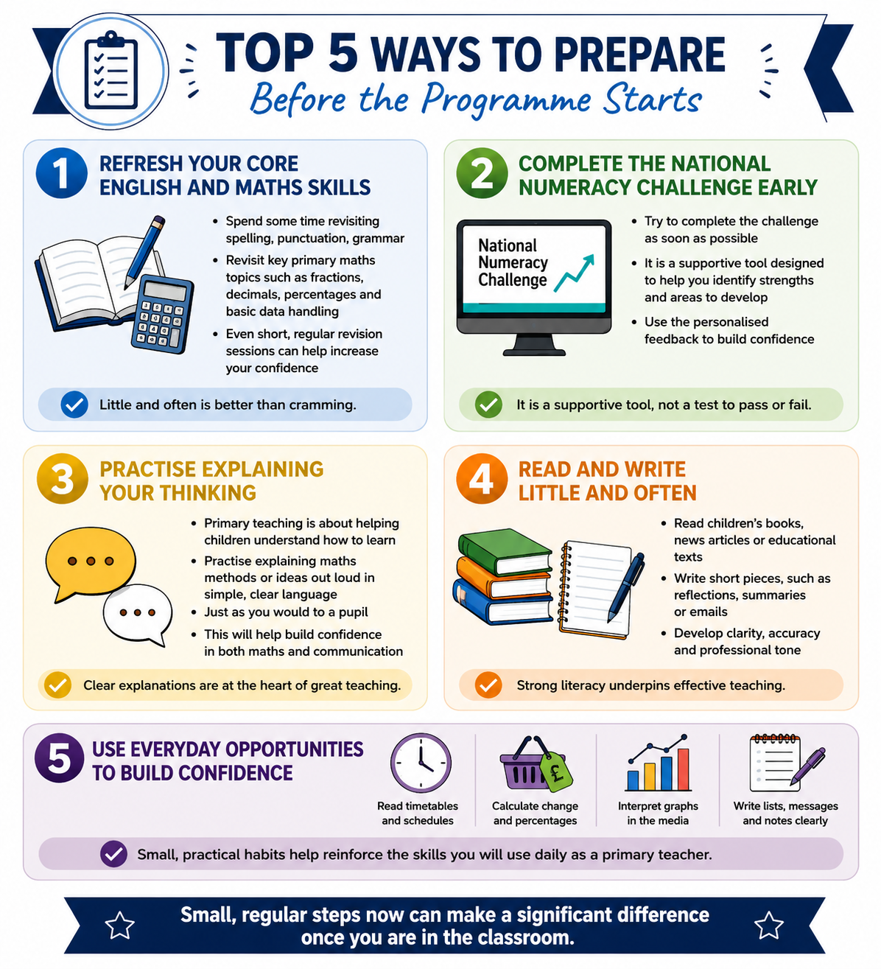

Section 4: Supporting your Mental Health and Wellbeing

Training to be a teacher can be incredibly rewarding, but it is also important to recognise that the PGCE is an intensive programme. Before the programme begins, you are strongly advised to give some thought to the frameworks and support you might put in place to help you on your journey. These prompts might help.

4.1 Your Personal Support Network
- Who do you call on when you need support? Think about your family, friends, and the wider community. They are all going to be important for you during your PGCE year. They can be there when you need a boost.They will be there to make sure you look after yourself. Don’t underplay their importance. Start building that community of support now.
- Think about your GP and/or any health professionals who currently offer you support. Will you need to change them if you move location?
- Accessing Disabled Students Allowance (DSA)-. If you are studying for a PGCE with a disability you may be eligible to apply for additional support. If you think this might be the case, start the process now as you may need to call on a range of professionals to support your application

4.2 Useful Websites for External Support
You may find the following useful in helping you prepare for starting the programme. We will share others with you during the year.
- NHS Every Mind Matters
You are asked five short questions in an interactive quiz and, based on your responses you will be emailed a tailored Mind Plan. I have had a go at this and found it useful. Many of this year’s PGCE students found it helpful too.
- Eat Well
We all know that we should eat healthily but it is easy to slip into ‘lazy’ eating when we are busy.
- Simple Self-Soothe Strategies - Creative Education
You will need to register on the site. It is quick and it is currently free. There are activities such as: Massage your Hands and Close Your Eyes and Look Inwards. You might also want to use some of these activities whilst on school-based training with some of your pupils.
- Mental health resources for children, students, parents, carers and school/college staff - Education in the media (blog.gov.uk)
This site has a wealth of resource links including helpful Apps. There is a useful short explanation about each resource link. It also provides information about Education in the media so it will help you keep abreast of some of the debates.

4.3 Support Available from Leeds Trinity
- You will work close with your tutors and other expert colleagues during the PGCE programme and will have a lot of opportunities to receive support and guidance from them.
- You are encouraged to be as open as you feel you can be about any challenges that you might be facing. We can only act and provide support if we are aware.
- The following webpage will provide information about the support you can expect from the University: Student support and wellbeing - Leeds Trinity University

Section 5: Recommended Reading

All the reading below can be accessed online. You do not need to read every document, in detail, but familiarising yourself with the overarching themes will support you as you begin the programme in September.

Department for Education. (2019). Initial Teacher Training (ITT): Core Content Framework. Accessible from:
Initial teacher training (ITT): core content framework - GOV.UK (www.gov.uk)

Pomerance, L., Greenberg, J. and Walsh, K. (2016). Learning about Learning: What Every New Teacher Needs to Know. National Council on Teacher Quality. Available from: https://www.nctq.org/dmsView/Learning_About_Learning_Report

Education Endowment Foundation (2018) Sutton Trust-Education Endowment Foundation Teaching and Learning Toolkit: Accessible from: Teaching and Learning Toolkit (educationendowmentfoundation.org.uk)

Deans for Impact (2015) The Science of Learning [Online] Accessible from:
The Science of Learning | Deans for Impact

Education Endowment Foundation (2021) Cognitive science approaches in the classroom: a review of the evidence. Accessible from:
Cognitive_science_approaches_in_the_classroom_-_A_review_of_the_evidence.pdf (d2tic4wvo1iusb.cloudfront.net)

Education Endowment Foundation (2017) Metacognition and Self-regulated learning Guidance Report. [Online] Accessible from: Guidance reports | EEF (educationendowmentfoundation.org.uk)

Department for Education. (2019). The trainee teacher behavioural toolkit: a summary. Accessible from:
The trainee teacher behavioural toolkit: a summary - GOV.UK (www.gov.uk)

You should also purchase

Stephenson, M. and Gill, A. (Eds). (2024) Training to be a Primary School Teacher: ITT and

Beyond. Learning Matters.

