Secondary PGCE in Modern Foreign Languages (MFL)
Pre-course information 2026-2027
Before the start of the course, what can I be reading?
This is the core MFL reading. It would be great if you made a start on reading some of the books / articles below before you start the course in September. But don’t feel you have to buy / read them all!
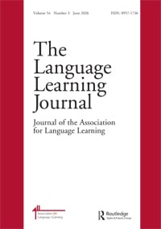 | Dobson, A. (2018). Towards “MFL for all” in England: a historical perspective. Language Learning Journal, 46(1), 71–85. https://doi.org/10.1080/09571736.2017.1382058
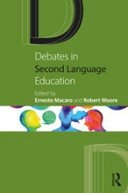 | Macaro, E., & Woore, R. (Eds.). (2022). Debates in second language education. Routledge
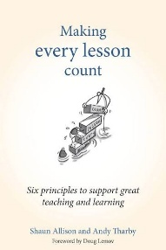 | Maxwell, J. A. (2019). Making every MFL lesson count six principles to support great foreign language teaching (S. Allison & A. Tharby, Eds.). Crown House Publishing
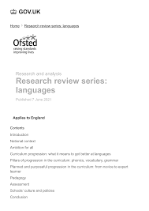 | Ofsted. (2021). Research Review Series: Languages. https://www.gov.uk/government/publications/curriculum-research-review-series-languages/curriculum-research-review-series-languages
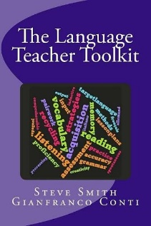 | Smith, S., & Conti, G. (2024). The language teacher toolkit (Second edition.).
Before the start of the course, what else can I be doing to prepare?
Here are a few other suggestions for things you can do before the course starts so that you feel well-prepared.
- Carefully read through and complete the MFL subject knowledge audit.
- Explore the Association for Language Learning (ALL). It is the best place to start when it comes to learning about all things related to language learning and teaching. I would strongly recommend becoming a member of the ALL too! (There’s a good discount for student members!). Home - Association for Language Learning.
- Explore some of these websites and blogs:
  - https://www.tes.com/teaching-resources
  - https://www.lightbulblanguages.co.uk
  - www.teachitlanguages.co.uk
  - https://www.informedlanguageteacher.com/
  - Second language teaching CPD 1 A process approach to listening: introduction (Steve Smith CPD on YouTube)
  - http://rachelhawkes.com
  - https://gianfrancoconti.com/
- Research the National Curriculum Key Stage 2 (7-11 years old) and Key Stage 3 (11 – 14 years old) Programmes of Study for Languages: KS2 Programme of Study for Languages 2013; KS3 Programme of Study for Languages 2013
- Read through the GCSE subject content for MFL: GCSE subject content for MFL 2024
- What does an outstanding lesson in MFL look like? – think about this over the summer so you can share your ideas in September
- Finally, inclusion is at the heart of our PGCE MFL curriculum, and it should also underpin your teaching. Read this article and begin to think about how you can ensure you promote inclusion in your classroom and professional practice: https://www.teachit.co.uk/cpd/languages/gender-neutral-language-and-mfl


