

PGCE History

Pre-Course Information & Tasks 2026-27

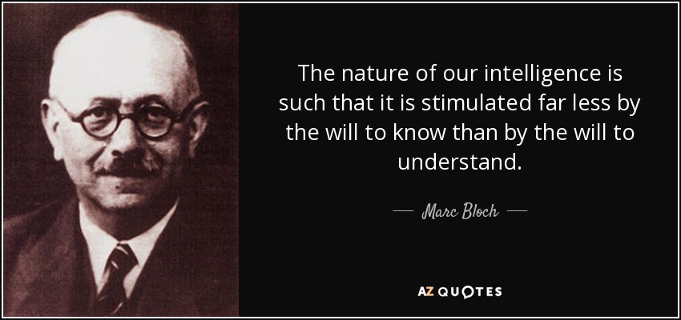

Welcome
Welcome to the Leeds Trinity PGCE History course. I am delighted that you will be joining the course this coming year and beginning the exciting and important work of teaching history in schools.
This booklet aims to give you everything you need to help you to prepare. Please make sure you read this information fully as many of the tasks will underpin the work we do in the first week.

Contact details
If you have any questions over the summer, please do not hesitate to get in touch.
Tutor | Email | Room | Bluesky
Alex Ford | a.ford@leedstrinity.ac.uk | S17 | @apf102.bsky.social

The aims of the Leeds Trinity history PGCE
School history is central to enabling young people to understand the world they live in. The past continues to shape the present in ways both seen and unseen. History teachers help young people to engage critically with the past and its legacies; appreciate the mentalities which drove people’s actions; explore their own identities and sense of belonging; and build capacity for them to act as informed citizens.

The Leeds Trinity History PGCE will enable you to help young people navigate history and appreciate its importance. This is done through rigorous, subject-specific professional training, with a strong focus on social justice and the needs of young people. During the course, you will be empowered to develop your own approaches to history teaching which give young people a voice and enable them to access diverse, inclusive, life-enhancing history.

Leeds Trinity History teachers are enabled to:
- Be subject experts and active in the debates of the wider subject community.
- Help young people understand the world they live in through the lens of history and further the cause of doing justice to the present through the study of history.
- Manage and develop excellent relationships with pupils, through which enthusiasm for historical learning can be shared.
- Use a deep understanding of the discipline of history to structure learning and plan for progression.
- Plan rigorous and motivating learning episodes based on the principles of the Schools History Project (SHP).
- Be professionally self-reflective and recognise their own professional needs.
- Exceed the basic Teachers’ Standards confidently.

As the home of the Schools History Project, the Leeds Trinity PGCE also seeks to promote SHP Principles. We aim to develop teachers who can help realise these principles in classrooms. The SHP Principles state that:
- School history should be relevant and meaningful to young people. History should connect to the lives and experiences of young people so that they can build a deeper understanding of the present world they live in through a respectful engagement with the past.
- School history should involve enquiry. Children should be encouraged to develop knowledge and engage with evidence in meaningful ways and in pursuit of real and rigorous historical questions. In this way, children should be introduced to the broader discipline of history and its methods.
- School history should build knowledge. Children and young people should be given opportunities to develop deeper knowledge of the past and a strong sense of period via robust chronological frameworks.
- School history should be diverse. Children should be given opportunities to engage with periods and placed beyond their own experiences. They should also have opportunities to “see themselves” in history through a curriculum which represents the diversity of modern Britain.
- School history should include ‘history around us’. Young people should be able to see how history has impacted upon the local world in which they live. They should see the living evidence of the past in sites, buildings and environments.
- School history should be enjoyable. Learning history should be a life-enhancing experience for all children and young people, providing the foundations for lifelong engagement with history.

Summer Tasks

Task 1: Consider the Purposes of History Teaching (Due 30 August)
We will talk a lot about moral purposes and being part of communities of practice during your training year. This task will serve two purposes. First to note some of the key issues in schools today and get you thinking about your own purposes in teaching. Second, to help me to get to know you a bit better.
- Before 30 August: Watch this short video on why we teach school history, HERE. Consider where you have encountered these different purposes of history education in your own schooling.
- Before 30 August: Click the link HERE to share YOUR thoughts on why learning about history is so important for young people in schools today. Just click the plus button under the correct heading and choose “video recorder” It doesn’t need to be long. You can also respond to other people’s posts.

Task 2: Join Subject & Teaching Associations (Due 7 September)
- Sign up to the HA by visiting www.history.org.uk – there is a discounted rate for trainee teachers. We also have institutional access, which you can access via the Library website.
- You should also sign up to join the Chartered College of Teaching: www.chartered.college . This is free.

Task 3: Preparatory Reading (Due 7 September)
The following are all items which you need to read in preparation for September. Some of these will help you with your subject knowledge audit, so there is definitely some useful overlap here.
Item | Task
An overview of British history covering the middle ages to C20th as a minimum (your choice) | - Pick an overview book on the history of Britain (or England if you cannot find one you like on the whole of the Isles). If you are stuck on what to choose, Michael Wood’s ‘Great British Story’ and David Olusoga’s ‘Black and British’ are very readable! THIS LINKS TO YOUR KS3 SUBJECT KNOWLEDGE DEVELOPMENT.  - Read your chosen book. As you read keep notes on:  - Stories which would get pupils interested  - Themes and links which run over time  - Key people and events you didn’t already have knowledge of  - Prepare a summary (1-2 pages of A4) in which you outline the big story (stories?) of the development of Britain according to your book ie. What is the story of Britain according to Wood, or Olusoga?  - Send your summary to Alex before the start of the course: a.ford@leedstrinity.ac.uk
How do we understand history? | - Use the search feature on the HA website to find the “information” pages on the following key terms. Write your own definitions of them.  - Substantive knowledge and substantive concepts  - Second Order concepts  - Causation; Similarity & Difference; Significance; Interpretations; Change & Continuity  - Bring your definitions with you in September. This will also help support your subject knowledge development.

Task 4: Go Stationery Shopping (Yay!)
Our sessions will often involve significant elements where you are trying activities out and doing things from a pupil perspective. Kit yourself out with all the things you’d need for a school history lesson: pens, paper, folders, highlighters, a few coloured pens etc. It never hurts to have a stapler, hole punch, board pen, post-its, or blutac either.

Task 5: Develop Your Subject Knowledge (Ongoing)
Your interview subject knowledge audit asked you to rate your knowledge of a whole range of content. Having excellent subject knowledge is crucial to being a great history teacher, especially in motivating pupils to care about the topics they are studying.
As history teachers we need to plan how best to increase our subject knowledge. Ultimately you will prioritise areas as you move through your training and first years in teaching. However, it is important that you have a broad overview of all the Key Stage 3 topic areas before you begin teaching.
Target your own areas of weakness in subject knowledge around KS3. Don’t forget you can go beyond the limits of the National Curriculum too! Make use of the following to get you started
- Statutory documents including:
  - The National Curriculum Programmes of Study
  - GCSE Subject Content
- Key Stage 3 textbooks – these can often be bought cheaply online or can be accessed digitally for a limited time for free. Hodder Education offer a good range of books HERE.
- Extended reading books – a great list can be found HERE.
- Specialist podcasts – the Historical Association offers a range of targeted podcasts related to the curriculum HERE. For more specialist podcasts you might also like to try more specialist podcasts like “You’re Dead to Me” HERE, “In Our Time” HERE, or “The History of England” HERE.

How to go about it…
Rather than just reading about subject knowledge you should aim to do tasks which will embed your understanding. This might include:
- Creating concept charts or maps
- Creating timelines and overviews
- Creating written summaries or narratives of key periods
- Answering exam questions on a topic area and using mark schemes to check your work
- Completing textbook questions from your chosen textbooks
- Anything else you find helpful
A basic format for recording key period overviews is given on the final page if you would like to use it.
Please note that there are a number of textbooks available covering history teaching which you may want to read, however, you will also have access to a number of core texts via the library from September. If you do wish to buy a core text, I would recommend:
- Davies, I (2017) Debates in History Teaching, 2nd Edition
- Thorne, S. (2018) Becoming an Outstanding History Teacher
- Bones, C. (2026) Clockwork Classrooms
- Husbands, C. (1996) What is History Teaching?

Useful links

Some useful watching

You can access Box of Broadcasts via your University account!

History of Britain:
- Michael Wood (2010) Story of England, BBC or Michael Wood (2011) Great British Story or Michael Wood (2013) The Anglo Saxons, BBC
- Fergal Keane (2011) Story of Ireland, BBC
- Bettany Hughes (2009) The Roman Invasion of Britain, BBC
- Robert Bartlett (2013) Inside the Medieval Mind, BBC
- Simon Schama (2006) A History of Britain, BBC
- David Olusoga (2016) Black and British
Bigger Picture:
- Henry Louis Gates (2017) Africa’s Great Civilizations, PBS/BBC
- Janina Ramirez (2019) Raiders of the Lost Past, BBC
- Schama, Beard & Olusoga (2018) Civilisations, BBC
- BBC/PBS (1995) People’s Century, BBC

Some useful listening

- Radio 4: In Our Time – A wide range of great 30-40 minute episodes. List of topics with links HERE.
- Historical Association Podcasts: Literally everything you might want HERE.
- You’re Dead to Me: A mixture of comedy and historians with Greg Jenner HERE

Great websites
I could make this huge, but I am going to recommend just a few here to get you thinking. Please avoid generic “sharing” sites like TES resources, or pay sites peddling their own pedagogies. These are OK to an extent, but they need an expert eye to sift through.
Website | Website
www.thinkinghistory.co.uk | www.spartacus-educational.com
www.schoolshistoryproject.co.uk | www.justice2history.org
https://curriculumpaths.schoolshistoryproject.co.uk | www.educationendowmentfoundation.org.uk
www.history.org.uk

You will also find a helpful bibliography for new teachers here: http://bit.ly/2KAzyMC

