MFL Pre-course information
¡Bienvenido! Bienvenue! Willkommen!

Before the start of the course, what can I be reading?
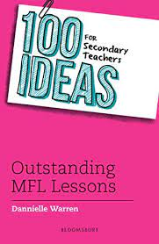
100 ideas for Secondary Teachers: Outstanding MFL Lessons – Dannielle Warren (2019)
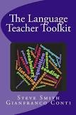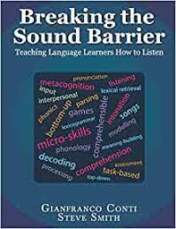
- The Language Teacher Toolkit (2016) – Steve Smith & Gianfranco Conti (not available as e-book)
- Breaking the Sound Barrier: teaching language learners how to listen (2019) – Gianfranco Conti & Steve Smith (not available as e-book)
Look at the websites for Association for Language Learning (ALL) Home - Association for Language Learning (all-languages.org.uk) and the National Centre for Excellence in Language Pedagogy NCELP – National Centre for Excellence for Language Pedagogy (NCELP).
Before the start of the course, what should I be doing to prepare?
- Complete the subject knowledge audit for the language you will be teaching, identifying any gaps in your subject knowledge
- Take a look at the National Curriculum for MFL: National Curriculum - Languages key stage 3 (publishing.service.gov.uk) Any comments?

- Have a go at a GCSE Fr/Sp/Gn paper. Familiarise yourself with the exam. board website (AQA, Pearson or Eduqas) and try to find the marking criteria so you can self-assess your work AQA | GCSE | French | Assessment resources
AQA | GCSE | Spanish | Assessment resources
AQA | GCSE | German | Assessment resources
- What does an outstanding lesson in MFL look like? – think about this over the summer so you can share your ideas in September
- Collate/Bookmark useful websites for good ideas and resources for teaching Fr/Sp/Gn- keep in order! (see list below for ideas)
- Look at “You Tube” clips for basic introduction to using an interactive whiteboard in the classroom (if you are not familiar with them)
- I would recommend looking at some of these websites:

MFL Online: websites and blogs for good quality resources
https://www.tes.com/teaching-resources
https://www.lightbulblanguages.co.uk
http://languagesresources.co.uk/home
https://mflresources.org.uk
www.teachitlanguages.co.uk
http://www.frenchteacher.net/
https://www.informedlanguageteacher.com/
www.pollyglotlanguages.wordpress.com
https://www.youtube.com/playlist?list=PL_FfkTb7PcMG7V_KE-N9r9NMmB1-GrF0c (Steve Smith CPD on YouTube)
http://rachelhawkes.com
https://gianfrancoconti.com/
http://maryglasgowplus.com/
http://www.mamalisa.com/?t=eh
http://lps13.free.fr/
www.bonjourdefrance.com

Facebook groups you might find helpful:
(You will need to request to join these closed FB groups prior to accessing)
• Secondary MFL Matters
• GILT – Global Innovative Language Teachers
• Teaching French
• Teaching German
• Teaching Italian
• Teaching Spanish
• MFL 9-1 GCSE Resources

