Pre-course activities: English
Before the start of the course, what can I be reading?
The three books below all offer a starting point in thinking about teaching English – but don’t feel you have to buy/read them all!
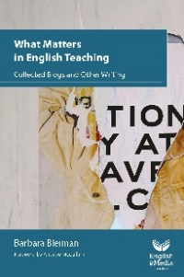
What matters in English teaching – Barbara Bleiman

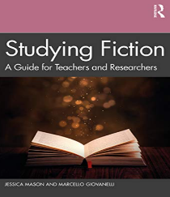
Studying Fiction: A Guide for Teachers and Researchers – Mason and Giovanelli

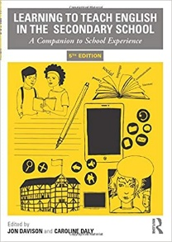

Learning to Teach English in the Secondary School – eds. Jon Davison and Caroline Davy

Also – have a look at the GCSE websites for AQA and Edexcel (the most popular exam board specifications) for their current set text lists, and at the websites for National Association for Teaching English (NATE) and the English and Media Centre (EMC). If you feel you haven’t read much teen fiction recently, you might try something from the Carnegie 2025 shortlist: https://carnegies.co.uk/writing-shortlist-2025/ If you are underconfident about Shakespeare, have a look at Macbeth and Romeo and Juliet, which remain the most popular GCSE choices.
Before the start of the course, what can I be doing to prepare?
- Complete the subject knowledge audit, identifying any gaps in your subject knowledge.

- Take a look at the National Curriculum for English: National curriculum in England: English programmes of study - GOV.UK (www.gov.uk)

- Have a go at a GCSE English paper to remind yourself of its challenges:
Insert: Paper 1 Explorations in creative reading and writing - June 2017 (aqa.org.uk)
https://filestore.aqa.org.uk/sample-papers-and-mark-schemes/2017/june/AQA-87001-QP-JUN17.PDF

