

PGCE Maths

Pre-Course Information

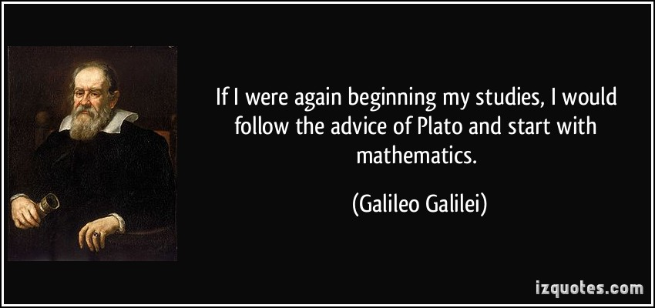

Welcome
Welcome to the Leeds Trinity PGCE Maths course. We are delighted that you will be training with us as a maths teacher from September. This booklet will give you everything you need to help you to prepare. Please make sure you read this information fully as many of the tasks will underpin the work we do in the first week.

Contact details
If you have any questions over the summer, please do not hesitate to get in touch.
Tutor | Email
Paul Rowlandson | p.rowlandson@leedstrinity.ac.uk

The aims of the Leeds Trinity maths PGCE
The Leeds Trinity PGCE course aims to develop excellent future maths teachers through a rigorous, school-centred, professional training approach. By the end of the course, you will have developed your own approaches to teaching which engage and excite pupils of all ages. In addition to meeting the Teacher Standards for QTS we want you to be engaged in becoming outstanding teachers of Mathematics!


Summer Tasks

Task 1: Developing Subject Knowledge

The subject knowledge audit you completed for your interview asked you to rate your knowledge of a whole range of content. Having excellent subject knowledge is crucial to being a good Maths teacher, especially in motivating pupils to care about the topics they are studying. It is also important that you have a broad overview of all the Key Stage 3 and Key Stage 4 topic areas before you begin teaching.
As maths teachers, it is important that we reflect on our subject knowledge regularly and plan how best to continue improving it over time. Therefore, subject knowledge audits will be used to tailor aspects of the Maths PGCE and in-school support for the cohort of trainees. Before starting the course in September, please fill out the subject knowledge audit again using the colour indicated in the ‘pre-course’ box.
There are many useful resources that you can access for free to help further develop your knowledge of the subject, knowledge of the mathematics curriculum and knowledge of GCSE assessments. The following would be highly recommended:
- National information documents about the mathematics curriculum:
  - National Curriculum for Maths for all Key Stages
  - Mathematics Guidance for Teaching Key Stage 3
  - GCSE Subject Content for Maths

- Past exam papers – downloading and completing past Maths GCSE and A-level papers, mark schemes and examiners reports will really help you address any weaknesses in subject content. The most commonly used exam boards are: www.edexcel.com and www.aqa.org.uk .

- Use Oak National Academy to view online resources for teachers and pupils. The website contains a full year’s worth of lesson for each year group. Every lesson contains resources for teachers and a video that are designed to be used for home learning or when a teacher is absent. This could be a useful website for revising any topics that you feel would benefit from a refresher.

Task 2: Exploring websites and resources

- You will find it helpful to have access to a scientific calculator during your school placement and subject-based university sessions. Casio calculators are most the widely used in schools and GCSE exams. The latest model that is becoming standard for schools is the Casio fx-83GT Classwiz.

- Register (for free) with the National Centre for Excellence in the Teaching of Mathematics www.ncetm.org.uk - whose aim is to improve mathematics teaching and share best practise and pedagogy.

- Register (for free) with the National Science Technology Engineering and Mathematics centre www.stem.org.uk. This site contains a host of amazing maths resources for the secondary classroom.

- There are three Maths Associations, one of them (if not all of them) will have membership offers for trainees: (1) Association of teachers of Mathematics www.atm.org.uk (2) The Mathematical Association www.m-a.org.uk (3) Institute of Maths and its Applications https://ima.org.uk. Each one has its only professional journal which provide thought provoking articles for maths teachers and could also be useful for your university studies.

- You can also sign up to join the Chartered College of Teaching: www.chartered.college, which is free for students.


Great websites
I could make this huge, but I am going to recommend just a few here to get you thinking. Please avoid generic “sharing” sites like TES resources, or pay sites peddling their own pedagogies. These are OK to an extent, but they need an expert eye to critically analyse them for quality and appropriateness.

Website | Website
www.thenational.academy | www.resourceaholic.com
www.mathsbot.com | polypad.amplify.com
www.bossmaths.com | www.mrbartonmaths.com
www.mathsgenie.co.uk | www.drfrostmaths.com

 Keeping in touch with the Maths world
Beyond websites you should also get on social media to start you off. Many influential and inspiring maths teachers can be found on Blue Sky. Look out for the #MathsToday, #UKMathsChat and #iTeachMaths hashtags for lots of quick ideas for teaching maths. Top follows include:

@mathsgem.bsky.social | @StudyMaths.bsky.social
@CatrionaAgg.bsky.social | @CorbettMaths.bsky.social
@profsmudge.bsky.social | @giftedhko.bsky.social
@draustinmaths.com | @blatherwicksam.bsky.social

Task 3: Preparatory Reading


Some useful Books
A range of books which will help you develop your understanding of maths, maths teaching, and the maths curriculum.

- Barton, C. (2018). How I Wish I’d Taught Maths: Lessons learned from research, conversations with experts, and 12 years of mistakes. John Catt Educational Ltd.
- McCrea, E. (2019). Making Every Maths Lesson Count: Six Principles to Support Great Maths Teaching. Crown House Publishing.
- Sherwood, J., Meek, A., Kennedy, C., & Weston, E. (2023). Succeeding as a Maths Teacher: The ultimate guide to teaching secondary maths. Bloomsbury Education.
- Southall, E. (2017). Yes, but why? Teaching for understanding in mathematics. SAGE Publications Ltd.

Task 4: Use this condensed topic revision list to really focus your subject knowledge development:

Number and Algebra
• Working with integers
• Factors, multiples, expressing a number as a product of prime factors, HCF, LCM
• Fractions
• Decimals
• Converting recurring decimals to fractions
• Power and Roots
• Set Theory
• Percentages including reverse percentages (finding the original quantity)
• Repeated percentage change and compound interest
• Ratio
• Estimating
• Decimal places
• Significant figures
• Upper and lower bounds
• Standard form
• Using a calculator
• Indices
• Basic algebra;
- substitution
- collecting like terms
- factorising by taking out common factors
- expanding brackets
- using algebra to solve real life problems
• Expanding three brackets
• Changing the subject of a formula
• Quadratic factorisation
• Solving quadratic equations by factorising
• Linear equations
• Simultaneous linear equations – algebraic and graphical
• Direct and inverse proportion
• Inequalities and shading regions
• Sequences - finding the nth term and arithmetic sequences
• Straight line graphs
Shape Space and Measure
• Angles and triangles
• Interior and exterior angles of polygons
• Angles and parallel lines; alternate, corresponding, allied
• Properties of polygons
• Understand congruence as meaning same size and same shape
• Line and rotational symmetry
• Three figure bearings
• Pythagoras theorem in 2 and 3 dimensions
• Right angled triangle trigonometry in 2 and 3 dimensions
• Advanced trigonometry - Sine and cosine rule and area of a triangle (Area = ½ absinC)
• Perimeter and area of 2D shapes including circles
• Surface area and volume of 3D shapes
• Arc length, sector and segment area
• Similar shapes including area and volume problems
• Transformations; enlargements, reflections, rotations, translations
• Scale drawing
• Constructions – angle bisector and perpendicular bisector of a line
• Calculate an estimate of the mean from a grouped frequency table
• Circle theorems including the intersecting chord theorem
Data Handling and Probability
• Probability
• Histograms
• Cumulative frequency including finding median and interquartile range
• Pictograms, bar charts, pie charts
• Mean, mode, median, range and interquartile range
Additional content….
• Vectors
• Functions
• Quadratic, cubic and reciprocal graphs
• Quadratic inequalities
• Find the gradient of a non linear graph by drawing a tangent
• Differentiation including linear kinematics
• Solving quadratic equations by using the formula and completing the square
• Graphical solution of equations
• Surds
• Solving simultaneous equations one linear and one quadratic
• Transforming graphs of functions

And finally please see the attached paper produced by the Joint Mathematical Council of the United Kingdom (JMC) with advice regarding how to develop Maths specific pedagogy for Initial Teacher Education.

