Leeds Trinity University

Annual Equality Information Update 2024–2025
(Public Sector Equality Duty – Equality Act 2010)

Contents
1. Executive Summary 3
2. Purpose of this Publication 3
3. The Public Sector Equality Duty 4
4. Equality Objectives (Current Cycle) 4
4.1 Published Equality Objectives 4
4.2 Progress During 2024-25 5
5. Institutional Action to Advance Race Equality (Race Equality Charter) 7
4.1 Governance and Oversight 7
5.2 Academic Provision 8
5.3 Workforce Processes 8
5.4 Monitoring and Reporting 8
6. Workforce Profile 9
6.1 Gender 9
6.2 Ethnicity 9
6.3 Nationality 9
6.4 Disability 10
6.5 Sexual Orientation 10
6.6 Age 10
6.7 Religion 11
6.8 Marital Status 11
6.9 Summary 11
7. Gender and Ethnicity Pay Gaps 12
7.1 Gender Pay Gap 12
7.2 Ethnicity Pay Gap 12
8. Talent Acquisition and Recruitment 13
8.1 Inclusive Hiring Manager Training 13
8.2 Values-Based Behavioural Interviewing 14
8.3 Senior Recruitment Framework 14
8.4 Recruitment Monitoring and Outcomes 14
9. Colleague Complaints and Grievances 15
9.1 Complaints and Grievances Reporting and Outcomes 16
10. Workforce Development, Leadership and Progression 17
11. Student Demographic Profile 17
11.1 New Entrants 18
11.2 Undergraduate Applications, Offers and Enrolments 19
11.3 Student Outcomes 20
11.4 Graduate Outcomes 23
12. Harassment, Complaints and Conduct 25
12.1 Student Complaints, Conduct and Casework 25
12.2 Colleague Complaints and Misconduct 29
13. Accessibility and Publication 31
14. Approval and Governance 31

1. Executive Summary
This report presents Leeds Trinity University’s annual published equality information for the period 1 August 2024 – 31 July 2025, in compliance with the Public Sector Equality Duty under the Equality Act 2010 and the Equality Act 2010 (Specific Duties) Regulations 2011.
The report outlines progress made towards the University’s equality objectives, which are delivered through the Equity, Social Justice and Belonging Strategy 2022–2026, alongside key initiatives including the Race Equality Charter (REC), the Access and Participation Plan, and institutional work to improve inclusive practice across teaching, research and professional services.
Key developments during the reporting period include:
- Continued implementation of the Race Equality Charter action plan, including initiatives to address differential student outcomes and strengthen race literacy across the institution.
- Expansion of inclusive recruitment practices, including mandatory Inclusive Hiring Manager training and values-based behavioural interviewing.
- Ongoing monitoring of workforce equality data across protected characteristics, supported by enhanced Power BI workforce dashboards.
- Continued monitoring of gender and ethnicity pay gaps, with a reduction in the ethnicity pay gap and stable gender pay gap figures compared with the previous reporting year.
- Monitoring of student access, participation and outcomes, including awarding gap analysis across key student characteristics.
The University remains committed to embedding equality considerations within institutional governance, policy development and operational practice. Progress against equality objectives continues to be monitored through the University’s governance framework, including oversight by the Equality, Diversity and Inclusion Committee.

2. Purpose of this Publication
This document constitutes Leeds Trinity University’s annual published equality information in compliance with:
- Section 149 of the Equality Act 2010 (Public Sector Equality Duty)
- Equality Act 2010 (Specific Duties) Regulations 2011 (England)
This report covers the period 1 August 2024 – 31 July 2025.
In accordance with Regulation 2(1), this document publishes annual equality information.
In accordance with Regulation 2(2), the University publishes and reports progress against its equality objectives.

3. The Public Sector Equality Duty
Under Section 149 of the Equality Act 2010, the University must, in the exercise of its functions, have due regard to the need to:
- Eliminate unlawful discrimination, harassment and victimisation and other prohibited conduct
- Advance equality of opportunity between persons who share a protected characteristic and those who do not
- Foster good relations between persons who share a protected characteristic and those who do not
The protected characteristics are:
- Age
- Disability
- Gender reassignment
- Marriage and civil partnership
- Pregnancy and maternity
- Race
- Religion or belief
- Sex
- Sexual orientation
“Due regard” requires that equality considerations are embedded in decision-making processes. The University implements this through Equality Impact Assessments and governance oversight mechanisms, as outlined in the Equity, Social Justice and Belonging Strategy 2022–2026

4. Equality Objectives (Current Cycle)

4.1 Published Equality Objectives
Leeds Trinity University’s published equality objectives are articulated through the Equity, Social Justice and Belonging Strategy 2022–2026, which provides the institutional framework for advancing equality, diversity and inclusion across the University community. The strategy supports the University’s responsibilities under the Public Sector Equality Duty and establishes a whole-institution approach to addressing structural inequalities affecting both students and colleagues.
The strategy identifies four strategic objectives which guide the University’s equality activity:
- Equitable access, experience and outcomes for students – ensuring that access, continuation, attainment, progression and graduate outcomes are not unfairly stratified by protected characteristics or background.
- Belonging and an environment which reflects a thriving community – creating an institutional culture in which students and colleagues feel that they belong, are valued and are able to participate fully in the life of the University.
- A Social Justice framework embedded across institutional practice – ensuring that institutional structures, policies, curricula and decision-making processes are informed by principles of equity and social justice.
- Improving race equity literacy and understanding of protected characteristics – supporting colleagues and students to develop knowledge and understanding which enables inclusive practice and equitable outcomes across the institution.
Progress towards these objectives is delivered through a range of institutional strategies and governance processes. Equality considerations are embedded within institutional planning, policy development and committee oversight. Work undertaken through initiatives such as the Race Equality Charter, the Access and Participation Plan, and institutional learning and development activities contributes to advancing these objectives across both the student and colleague experience.
Examples of activity contributing to progress against the equality objectives during the reporting period are set out below.

4.2 Progress During 2024-25
The REC action plan has functioned as a key delivery mechanism for several of the University’s equality objectives, enabling the institution to implement targeted interventions designed to address racial inequities in student outcomes, curriculum design, and institutional culture. Initiatives such as the Curriculum for Social Justice, the Race Equity Pathway, and the Re:Tension programme support the development of race literacy, inclusive pedagogic practice, and open dialogue about race and belonging within the University community.
Alongside curriculum and cultural initiatives, the University has strengthened its data infrastructure to support evidence-informed action. The development of centralised data dashboards and learner analytics tools enables programme teams and support services to identify and address disparities in student progression, attainment and engagement across demographic groups. These approaches support targeted interventions, including academic skills provision and mentoring programmes designed to improve outcomes for under-represented students.
The examples below illustrate how the published equality objectives have been operationalised through specific actions and programmes.
Equality Objectives | Key Actions Undertaken | Evidence of Progress
Equitable access, experience and outcomes for students | Targeted institutional activity to address differential student outcomes and attainment gaps | The undergraduate attainment gap between BAME and white students reduced from 13.1% (2022) to 10.7% (2023) and 9.4% (2024) following targeted institutional interventions.
Equitable access, experience and outcomes for students | Expansion of academic skills and learning support provision | Engagement with this provision was associated with improved student outcomes: for example, Level 4 pass rates were 87% of students engaging with the Learning Hub compared with 78% of those who did not.
Belonging and an environment which reflects a thriving community | Institution-wide belonging initiatives and student co-creation activity | A large-scale co-creation initiative has engaged approximately 3000 students and 400 colleagues supporting dialogue on belonging and contributing to institutional policy and practice development.
 | Institutional campaign supporting student belonging | The university-wide “LTU Belong” campaign was introduced across student communication platforms and digital services to strengthen students' sense of belonging.
A Social Justice framework embedded across institutional practice | Establishment of institutional infrastructure to support equity work | The Office for Institutional Equity (OIE) continues to provide strategic leadership for equity work and coordinate activity across academic and professional services areas.
 | Curriculum transformation through social justice approaches | Implementation of the Curriculum for Social Justice embedding inclusive and anti-racist pedagogical principles across academic programmes.
Improving race equity literacy and understanding of protected characteristics | Staff and student race equity learning initiatives | The Re:Tension programme addressing race microaggressions and institutional racism has been delivered to approximately 900 students and forms part of staff development provision.
 | Staff development to support race literacy and inclusive practice | The Race Equity Pathway professional development programme has been delivered to approximately 100 colleagues supporting reflective practice and inclusive teaching practices.
 | Improving representation in research pathways | Institutional changes to postgraduate research studentships increased BAME PGR enrolment from 8% (2020-21) to over 25% (2024-25).

Governance arrangements ensure that equality objectives are monitored through the University’s deliberative structures, including the Equality, Diversity and Inclusion Committee, faculty governance processes and the work of staff and student equity networks. The establishment of the Office for Institutional Equity further strengthened institutional oversight and coordination of equality, diversity and inclusion activity across the University.

5. Institutional Action to Advance Race Equality (Race Equality Charter)
The Race Equality Charter (REC) provides a structured framework through which higher education institutions identify racial inequalities and implement actions to address structural barriers affecting staff and students. The University’s REC activity contributes to the broader equality objectives outlined in Section 3 and forms part of the institution’s wider approach to advancing equity and inclusion.
During the reporting period 1 August 2024 – 31 July 2025, the University continued to progress race equality work through this framework. In June 2025, the University submitted its Race Equality Charter Silver application, following a structured institutional self-assessment process involving staff, students and senior leadership. The submission included an institutional action plan addressing race equity across governance, academic provision and workforce processes.

4.1 Governance and Oversight
Race equality activity is supported through the University’s governance framework.
The Office for Institutional Equity (OIE) provides strategic oversight of race-related work and coordinates activity across academic and professional services areas. Updates relating to race equality activity are reported through established executive and committee structures, including the Equality, Diversity and Inclusion Committee, which maintains oversight of equality work.
Race equity is also considered within wider institutional governance processes. Relevant committees receive updates on REC activity and associated initiatives, supporting consideration of equality impacts within institutional decision-making.

5.2 Academic Provision
Academic governance processes support the monitoring and review of student outcomes across demographic groups.
Programme review and enhancement cycles require academic teams to analyse student performance data by ethnicity and consider patterns relating to continuation, attainment and progression. Where disparities are identified, programme teams are expected to reflect on potential contributing factors and identify appropriate actions through established academic review processes.
During the reporting period, the University initiated a pilot relating to Racially Inclusive Practice in Assessment Guidance, which seeks to evaluate how assessment design and practice may contribute to differential outcomes.

5.3 Workforce Processes
Workforce processes also contribute to the University’s approach to advancing race equality.
Workforce data continues to be monitored by protected characteristic to support review of patterns in recruitment, representation and progression. Inclusive recruitment training remains available for hiring managers, and recruitment monitoring tools are used to analyse candidate progression through selection processes.
These measures support the University’s ongoing work to promote equitable recruitment and workforce development.

5.4 Monitoring and Reporting
Institutional monitoring mechanisms support oversight of equality-related concerns and reporting processes.
Employee relations cases are recorded through a centralised case management system, enabling the University to monitor cases, including those relating to race. Reporting mechanisms remain under review to ensure appropriate routes are available for colleagues and students to raise concerns.
Race equality actions are embedded within the Equity, Social Justice and Belonging Strategy (2022–2026) and are monitored through established governance structures to ensure continued oversight and accountability.

6. Workforce Profile
Understanding the composition of the University’s workforce is an important element of advancing equity and monitoring progress against institutional equality objectives. Workforce data enables the University to identify patterns in representation, recruitment and progression across the colleague lifecycle.
As at 31 March 2025, there were 917 colleagues employed by the University. The tables below illustrate the breakdown of the workforce by protected characteristic.
Where numbers are very small, values have been suppressed and reported as “<10” in order to protect the confidentiality of individuals.

6.1 Gender
Gender | Percentage
Female | 62.5%
Male | 37.5%
The data reflects a workforce profile that is broadly consistent with trends across the higher education sector, where women are more highly represented across many professional and academic roles.

6.2 Ethnicity
Ethnicity | Percentage
Global Majority | 13.6%
White | 80.1%
Prefer not to say | 6.3%

This information supports the University’s monitoring of workforce diversity and progress toward its institutional target of 20% Global Majority representation by 2026.

6.3 Nationality
Nationality | Percentage
Non-UK | 8.9%
UK | 89.7%
Prefer not to say | 1.4%
The data indicates the proportion of international colleagues is lower than the UK higher education sector average, where approximately one quarter of staff are non-UK nationals.

6.4 Disability
Disability | Percentage
Disabled | 10.1%
Not Disabled | 77.9%
Prefer not to say | 11.9%
Analysis of the data shows that a number of colleagues have chosen not to disclose their disability status. Increasing declaration rates remains important to support accurate monitoring of workforce representation and to inform institutional policy and practice.

6.5 Sexual Orientation
Sexual Orientation | Percentage
Bisexual | 2.3%
Gay Man | 1.4%
Gay Woman / Lesbian | 1.5%
Heterosexual | 81.0%
Other | 1.2%
Prefer not to say | 12.6%
Similar to disability reporting, a notable proportion of colleagues have chosen not to disclose their sexual orientation, which is consistent with patterns often observed for more sensitive equality monitoring characteristics.

6.6 Age
Age Band | Percentage
20-29 | 11.3%
30-39 | 25.2%
40-49 | 29.4%
50-59 | 24.5%
60-64 | 7.4%
65+ | 2.2%
The age profile reflects a workforce with strong representation across mid-career stages, alongside colleagues at earlier and later career points.

6.7 Religion
Religion | Percentage
Christian | 34.9%
Hindu | <1%
Jewish | <1%
Muslim | 4.5%
No Religion | 41.9%
Sikh | <1%
Spiritual | 1.4%
Any Other Religion or Belief | <1%
Prefer not to say | 14.8%
The data indicates that colleagues identify with a range of religions and beliefs, alongside a substantial proportion who report having no religion.

6.8 Marital Status
Marital Status | Percentage
Civil Partnership | 2.9%
Divorced | 3.7%
Married | 47.7%
Separated | 1.1%
Single | 31.0%
Widowed | <1%
Prefer not to say | 13.3%
The marital status profile reflects a workforce with a range of personal circumstances and household arrangements.

6.9 Summary
The University continues to strengthen workforce data monitoring through the implementation of People and Culture dashboards using Power BI, which provide Heads of School and Directors with improved access to workforce equality data. These dashboards support the monitoring of representation across protected characteristics and enable a more data-informed approach to workforce planning, recruitment and progression.

7. Gender and Ethnicity Pay Gaps
Leeds Trinity University continues to monitor gender and ethnicity pay gaps as part of its commitment to advancing workforce equity and transparency.

7.1 Gender Pay Gap
As at 31 March 2025, the University’s mean gender pay gap was 11.9%, with a median pay gap of 13.3%.
This compares with the Higher Education sector benchmark (UCEA 2024) of:
Measure | LTU | Sector Benchmark
Mean gender pay gap | 11.9% | 12.0%
Median gender pay gap | 13.3% | 11.0%

The University’s mean gender pay gap has remained broadly stable compared with the previous reporting year.
Analysis of pay quartile distribution indicates that women are well represented across upper and middle pay quartiles; however, a large proportion of women remain in lower-paid roles. As at March 2025:
Pay Quartile | Female | Male
Top Quartile | 52.2% | 47.8%
Upper Middle Quartile | 55.0% | 45.0%
Lower Middle Quartile | 66.8% | 33.2%
Lower Quartile | 73.4% | 26.6%
This distribution contributes to the overall gender pay gap and remains an area for institutional focus.
No bonus payments were made to colleagues during the reporting period and therefore no gender bonus pay gap was reported.

7.2 Ethnicity Pay Gap
The University also voluntarily reports ethnicity pay gap data as part of its commitment to transparency and accountability.
As at 31 March 2025, the University reported:

Measure | LTU
Mean ethnicity pay gap | -0.75%
Median ethnicity pay gap | 0.0%

This represents a significant improvement compared with the previous reporting year, when the mean pay gap was 2.5% and the median pay gap was 13.7%.
A negative mean pay gap indicates that, on average, Global Majority colleagues’ hourly earnings slightly exceed those of White colleagues across the workforce.
Pay quartile analysis shows the following representation across grades:
Pay Quartile | Global Majority | White
Top Quartile | 12.9% | 87.1%
Upper Middle Quartile | 17.4% | 82.6%
Lower Middle Quartile | 13.9% | 86.1%
Lower Quartile | 14.4% | 85.6%

The reduction in the ethnicity pay gap reflects improvements in recruitment practices, increased representation across grades and strengthened governance.

8. Talent Acquisition and Recruitment
The University continues to strengthen recruitment practices to support fairness, transparency and diversity across the workforce.

8.1 Inclusive Hiring Manager Training
Mandatory Inclusive Hiring Manager training has been introduced for all hiring managers to support equitable recruitment practices. The training focuses on recognising bias, conducting inclusive recruitment processes and improving the candidate experience.
To date, 184 managers have completed the training, supporting the development of consistent and inclusive recruitment practices across the institution.
The programme covers key areas including:
- Recognising bias and its impact on recruitment
- Inclusive shortlisting and selection practices
- Behavioural interviewing approaches
- Improving the candidate experience
- Attracting diverse talent within a competitive labour market

8.2 Values-Based Behavioural Interviewing
During the reporting period, the University introduced a new interview builder platform incorporating more than 240 behaviourally based interview questions linked to institutional values and behaviours.
This structured approach ensures that candidates are assessed against consistent criteria aligned with institutional values, reducing reliance on unstructured interview questions which may introduce bias.
Each question includes clear assessment criteria and integrates equality, diversity and inclusion considerations to ensure candidates demonstrate awareness of inclusive practice as part of the recruitment process.
The University also introduced a four-point scoring scale for interview assessments. This approach supports fairer comparisons between candidates and reduces the potential for bias associated with “perfect score” assessments.

8.3 Senior Recruitment Framework
Following feedback from staff engagement surveys, the University implemented a Senior Hiring Recruitment Framework designed to strengthen consistency and fairness in recruitment to senior roles.
Key elements of the framework include:
- Guidance on panel composition and interview structures
- Mandatory external panel members for senior appointments
- Inclusive person specification development
- Advance sharing of interview themes with candidates
- Mandatory equality, diversity and inclusion interview questions
- Values-based assessment processes
- Independent panel scoring to reduce group bias
These measures aim to strengthen fairness, improve candidate experience and support the development of a diverse leadership pipeline.

8.4 Recruitment Monitoring and Outcomes
Recruitment monitoring data is used to assess progression through recruitment stages and identify potential disparities in candidate outcomes. Monitoring recruitment pipelines allows the University to understand how candidates from different backgrounds progress through shortlisting, interview and appointment stages and supports evidence-informed improvements to recruitment practice.
Analysis of recruitment pipeline data indicates variation in progression between demographic groups at interview and appointment stages. For example, 8.2% of Global Majority (reported as ABMO) applicants progressed to interview compared with 15.5% of White applicants, while 1.6% of Global Majority candidates were appointed compared with 6.0% of White candidates, as illustrated below:
Applicant Stages by Ethnicity
Applicant Group | Decline after CV Review | Screened | Interviewed | Appointed
ABMO | 49.2% | 41.0% | 8.2% | 1.6%
White | 42.2% | 36.3% | 15.5% | 6.0%
Prefer not to say (ethnicity) | 54.2% | 45.2% | 0.0% | 0.0%

A similar pattern is observed when considering nationality, with 14.8% of British applicants progressing to interview compared with 4.9% of Non-UK applicants, and 5.2% of British applicants appointed compared with 1.2% of Non-UK applicants, as demonstrated in the deeper analysis below:
Applicant Stages by Nationality
Applicant Group | Decline after CV Review | Screened | Interviewed | Appointed
British | 41.8% | 38.2% | 14.8% | 5.2%
Non-UK | 55.5% | 38.4% | 4.9% | 1.2%
Prefer not to say (nationality) | 50% | 50% | 0.0% | 0.0%

These insights inform ongoing improvements to recruitment practice, including structured behavioural interviewing, mandatory inclusive hiring manager training and strengthened governance of recruitment processes.

9. Colleague Complaints and Grievances
The University maintains policies and procedures to support a respectful and inclusive working environment and to address concerns relating to bullying, harassment, discrimination and misconduct.
The Bullying, Harassment and Sexual Misconduct Policy sets out the University’s commitment to maintaining a safe and respectful environment for all employees. The policy establishes clear processes for reporting inappropriate behaviour and for resolving concerns through both informal and formal procedures.
The policy confirms that the University does not tolerate behaviours such as bullying, harassment, victimisation, discrimination or sexual misconduct and sets out expectations regarding professional conduct across the institution. It also outlines the responsibilities of colleagues, managers and the People and Culture team in addressing concerns and supporting those involved in reporting processes.
The University also maintains a Dignity at Work and Study Policy, which establishes expectations for respectful behaviour across the University community and provides procedures for addressing complaints relating to harassment or bullying.
Colleagues are encouraged to raise concerns through established routes, including line managers, the People and Culture team, trade union representatives or formal grievance procedures. Concerns may also be raised through the University’s online reporting tool, which allows disclosures to be submitted confidentially or anonymously.
Where complaints are received, they are assessed and investigated in line with the relevant institutional procedures. Cases are monitored through a centralised case management system, enabling the University to track employee relations matters and ensure appropriate oversight.
This framework supports fair, transparent and consistent processes for addressing concerns while promoting a workplace culture grounded in dignity, respect and equality.

9.1 Complaints and Grievances Reporting and Outcomes
During the reporting period a small number of colleague grievances were recorded relating to bullying and discrimination. The majority of concerns were resolved through informal processes, reflecting the University’s emphasis on early resolution where appropriate.
Due to the very small number of cases recorded during the reporting period, individual figures have not been reported to protect colleague confidentiality. Instead, the table below indicates where case numbers fall below ten.
Issue Raised | Number of Cases | Outcome
Bullying | <10 | Informally resolved
Gender discrimination | <10 | Informally resolved / not upheld
Race discrimination | <10 | Informally resolved
Religion discrimination | <10 | Informally resolved
Informal grievance | <10 | Informally resolved

Equality monitoring data associated with these cases indicates that concerns were raised by colleagues across a range of demographic groups. No clear concentration of complaints was identified within any single protected characteristic group.

10. Workforce Development, Leadership and Progression
Developing inclusive leadership and strengthening progression pathways across the workforce are key components of the University’s approach to advancing equity.
Institutional initiatives supporting workforce development include leadership development programmes, mentoring opportunities and targeted career development initiatives designed to strengthen progression pathways across academic and professional services roles.
Alongside these initiatives, the University continues to invest in leadership capability through the implementation of the Leadership Framework and the Mental Health and Wellbeing Strategy, both of which were informed by colleague engagement and pulse surveys. These frameworks support the development of inclusive leadership behaviours and aim to strengthen organisational culture across the institution.
Together, these initiatives support the University’s commitment to developing an inclusive workforce and strengthening equitable progression opportunities across all areas of the institution.

11. Student Demographic Profile
The University publishes equality information relating to students to demonstrate compliance with the Public Sector Equality Duty under the Equality Act 2010. This information supports the monitoring of access, participation and student outcomes across different student groups. This includes information relating to:
- age profile
- ethnicity
- sex
- disability disclosure
Student equality data is reviewed through institutional processes including annual programme review and academic governance structures. Where appropriate, this information informs actions aimed at addressing differential outcomes between student groups.
Where numbers are small, data have been suppressed to protect student confidentiality.

11.1 New Entrants
The University monitors the demographic profile of students enrolling each year in order to understand patterns of participation and representation across different groups.
For the 2024–2025 academic year, the demographic profile of new entrants (excluding apprenticeships and franchise provision) is summarised in the tables below. New entrant data reflects enrolments as at the institutional census date.
These data provide an overview of the composition of the student body and support monitoring of representation across protected characteristics.

11.1.1 Disability
Disability | Category Total |  | Undergraduate |  | Postgraduate
Disability | Number | % | Number | % | Number | %
Specified Learning Disability Declared | 140 | 7.71% | 85 | 9.71% | 55 | 5.84%
Other Disability Declared | 228 | 12.55% | 144 | 16.46% | 84 | 8.92%
No Disability Declared | 1404 | 77.27% | 628 | 71.77% | 776 | 82.38%
Unknown | 45 | 2.48% | 18 | 2.06% | 27 | 2.87%
Total | 1817 (100%) |  | 875 (100%) |  | 942 (100%)

11.1.2 Age
Age | Category Total |  | Undergraduate |  | Postgraduate
Age | Number | % | Number | % | Number | %
Young (Under 21) | 715 | 39.35% | 712 | 81.37% | 3 | 0.32%
Mature (21+) | 1102 | 60.65% | 163 | 18.63% | 939 | 99.68%
Total | 1817 (100%) |  | 875 (100%) |  | 942 (100%)

11.1.3 Gender
Gender | Category Total |  | Undergraduate |  | Postgraduate
Gender | Number | % | Number | % | Number | %
Female | 1125 | 61.93% | 534 | 61.03% | 591 | 62.74%
Male | 661 | 36.38% | 317 | 36.23% | 344 | 36.52%
Other | 31 | 1.71% | 24 | 2.74% | 7 | 0.74%
Total | 1817 (100%) |  | 875 (100%) |  | 942 (100%)

11.1.4 Ethnicity
Ethnicity | Category Total |  | Undergraduate |  | Postgraduate
Ethnicity | Number | % | Number | % | Number | %
Asian | 442 | 24.33% | 155 | 17.71% | 287 | 30.47%
Black | 157 | 8.64% | 78 | 8.91% | 79 | 8.39%
Mixed | 80 | 4.40% | 48 | 5.49% | 32 | 3.40%
Other | 30 | 1.65% | 21 | 2.40% | 9 | 0.96%
White | 1092 | 60.10% | 569 | 65.03% | 523 | 55.53%
Unknown | 16 | 0.88% | 4 | 0.46% | 12 | 1.27%
Total | 1817 (100%) |  | 875 (100%) |  | 942 (100%)

11.1.5 Deprivation Index (IMD)
IMD Quintile | Category Total |  | Undergraduate |  | Postgraduate
IMD Quintile | Number | % | Number | % | Number | %
Quintile 1 (Most Deprived) | 548 | 30.16% | 342 | 39.09% | 206 | 21.88%
Quintile 2 | 279 | 15.36% | 151 | 17.26% | 128 | 13.59%
Quintile 3 | 251 | 13.81% | 121 | 13.83% | 130 | 13.80%
Quintile 4 | 275 | 15.14% | 137 | 15.66% | 138 | 14.65%
Quintile 5 (Least Deprived) | 212 | 11.67% | 90 | 10.29% | 122 | 12.96%
Unknown / Not Applicable | 252 | 13.87% | 34 | 3.89% | 218 | 23.15%
Total | 1817 (100%) |  | 875 (100%) |  | 942 (100%)
*e.g. overseas students

11.2 Undergraduate Applications, Offers and Enrolments
The University monitors recruitment and enrolment data to understand access to higher education across different groups of applicants.
Data relating to undergraduate applications, offers and enrolments for the 2024–2025 entry cycle is summarised in the tables below. These data relate to undergraduate provision only and exclude apprenticeship and franchise provision.
This includes application, offer and enrolment data by key demographic characteristics.

11.2.1 Disability
Disability | Applications |  | Offers |  | Enrolments
 | Number | % Total | Number | % Total | Number | % Total
Specified Learning Disability Declared | 468 | 5.76% | 372 | 6.36% | 72 | 8.20%
Other Disability Declared | 1339 | 16.49% | 990 | 16.92% | 149 | 16.97%
No Disability Declared | 6247 | 76.92% | 4452 | 76.10% | 643 | 73.23%
Unknown | 67 | 0.83% | 36 | 0.62% | 14 | 1.59%
Total | 8121 (100%) |  | 5850 (100%) |  | 876 (100%)

11.2.2 Age
Age | Applications |  | Offers |  | Enrolments
 | Number | %Total | Number | %Total | Number | %Total
Young (Under 21) | 7017 | 87.07% | 5309 | 90.75% | 715 | 81.62%
Mature (21+) | 1104 | 12.93% | 541 | 9.25% | 163 | 18.38%
Total | 8121 (100%) |  | 5850 (100%) |  | 876 (100%)

11.2.3 Gender
Gender | Applications |  | Offers |  | Enrolments
 | Number | %Total | Number | %Total | Number | %Total
Female | 4907 | 60.42% | 3597 | 61.49% | 534 | 60.96%
Male | 3091 | 38.06% | 2162 | 36.96% | 320 | 36.53%
Other | 123 | 1.51% | 91 | 1.55% | 24 | 2.74%
Total | 8121 (100%) |  | 5850 (100%) |  | 876 (100%)

11.2.4 Ethnicity
Ethnicity | Applications |  | Offers |  | Enrolments
 | Number | % Total | Number | % Total | Number | % Total
Asian | 1479 | 18.21% | 1048 | 17.91% | 155 | 17.65%
Black | 556 | 6.85% | 323 | 5.52% | 73 | 8.31%
Mixed | 399 | 4.91% | 290 | 4.96% | 50 | 5.69%
Other | 147 | 1.81% | 93 | 1.59% | 19 | 2.16%
White | 4782 | 58.88% | 3823 | 65.35% | 575 | 65.49%
Unknown | 758 | 9.33% | 273 | 4.67% | 6 | 0.68%
Total | 8121 (100%) |  | 5850 (100%) |  | 876 (100%)

11.2.5 Deprivation Index (IMD)
Deprivation Index (IMD) | Applications |  | Offers |  | Enrolments
 | Number | % Total | Number | % Total | Number | % Total
Quintile 1 (Most Deprived) | 2714 | 33.42% | 1866 | 31.90% | 347 | 39.61%
Quintile 2 | 1347 | 16.59% | 1033 | 17.66% | 154 | 17.58%
Quintile 3 | 1084 | 13.35% | 833 | 14.24% | 122 | 13.93%
Quintile 4 | 1171 | 14.42% | 954 | 16.31% | 135 | 15.41%
Quintile 5 (Least Deprived) | 1028 | 12.66% | 841 | 14.38% | 89 | 10.16%
Unknown/Not Applicable* | 777 | 9.57% | 323 | 5.52% | 31 | 3.54%
Total | 8121 (100%) |  | 5850 (100%) |  | 876 (100%)
*e.g. overseas students
Monitoring recruitment and enrolment patterns enables the University to identify trends in access and participation and supports institutional planning in relation to widening participation and equality of opportunity.

11.3 Student Outcomes
The University monitors student outcomes to identify any differential attainment between student groups. This analysis is undertaken as part of the University’s annual academic review processes.
Awarding gap analysis considers differences in outcomes between student groups, including comparisons relating to ethnicity, disability and other characteristics where data are available.
Where numbers are small, outcomes are suppressed to protect student confidentiality.

11.3.1 Undergraduate Student Outcomes
Disability | 1st | 2:1 | 2:2 | 3rd | 1st/2:1 % | Awarding Gap (to No Disability)
Specified Learning Disability Declared | 12 | 21 | 5 | 1 | 84.6% | +7.7%
Other Disability Declared | 36 | 36 | 19 | 3 | 76.6% | -0.3%
No Disability Declared | 132 | 181 | 85 | 9 | 76.9% | N/A
Unknown | 3 | 5 | 2 | 0 | 80.0% | +3.1%
Age | 1st | 2:1 | 2:2 | 3rd | 1st/2:1 % | Awarding Gap (to Young)
Young (Under 21) | 123 | 204 | 95 | 10 | 75.7% | N/A
Mature (21+) | 60 | 39 | 16 | 3 | 83.9% | +8.2%
Gender | 1st | 2:1 | 2:2 | 3rd | 1st/2:1 % | Awarding Gap (to Female)
Female | 139 | 158 | 60 | 7 | 81.6% | N/A
Male | 44 | 84 | 49 | 6 | 69.9% | -11.6%
Other | <10 | <10 | <10 | <10 | N/A | <10 Graduates
Ethnicity | 1st | 2:1 | 2:2 | 3rd | 1st/2:1 % | Awarding Gap (to No White)
Asian | 20 | 41 | 19 | 1 | 75.3% | -3.3%
Black | 4 | 15 | 9 | 2 | 63.3% | -15.3%
Mixed | 8 | 14 | 5 | 1 | 78.6% | -0.1%
Other | <10 | <10 | <10 | <10 | N/A | <10 Graduates
White | 143 | 170 | 76 | 9 | 78.6% | N/A
Unknown | <10 | <10 | <10 | <10 | N/A | <10 Graduates
Deprivation Index (IMD) | 1st | 2:1 | 2:2 | 3rd | 1st/2:1 % | Awarding Gap (to Quintile 5)
Quintile 1 (Most Deprived) | 47 | 72 | 32 | 6 | 75.8% | -2.0%
Quintile 2 | 26 | 45 | 21 | 3 | 74.7% | -3.0%
Quintile 3 | 42 | 28 | 22 | 0 | 76.1% | -1.7%
Quintile 4 | 34 | 62 | 14 | 2 | 85.7% | +7.9%
Quintile 5 (Least Deprived) | 20 | 29 | 14 | 0 | 77.8% | N/A
Unknown/Not Applicable* | 14 | 7 | 8 | 2 | 67.7% | -10.0%
*e.g. overseas students

11.3.2 Postgraduate Student Outcomes
Disability | Total Awards | Pass | Merit | Distinction | Distinction % | Awarding Gap (to No Disability)
Specified Learning Disability Declared | 48 | 9 | 20 | 19 | 39.6% | +0.1%
Other Disability Declared | 79 | 10 | 33 | 36 | 45.6% | +6.1%
No Disability Declared | 568 | 108 | 236 | 224 | 39.4% | N/A
Unknown | 18 | 1 | 8 | 9 | 50.0% | +10.6%
Gender | Total Awards | Pass | Merit | Distinction | Distinction % | Awarding Gap (to Female)
Female | 528 | 76 | 226 | 226 | 42.8% | N/A
Male | 181 | 52 | 69 | 60 | 33.1% | -9.7%
Other | <10 | <10 | <10 | <10 | N/A | <10 Graduates
Ethnicity | Total Awards | Pass | Merit | Distinction | Distinction % | Awarding Gap (to White)
Asian | 132 | 40 | 62 | 30 | 22.7% | -23.6%
Black | 38 | 7 | 22 | 9 | 23.7% | -22.7%
Mixed | 23 | 7 | 9 | 7 | 30.4% | -15.9%
Other | <10 | <10 | <10 | <10 | N/A | <10 Graduates
White | 505 | 72 | 199 | 234 | 46.3% | N/A
Unknown | <10 | <10 | <10 | <10 | N/A | <10 Graduates
Deprivation Index (IMD) | Total Awards | Pass | Merit | Distinction | Distinction % | Awarding Gap (to Quintile 5)
Quintile 1 (Most Deprived) | 161 | 42 | 73 | 46 | 28.6% | -24.7%
Quintile 2 | 112 | 21 | 54 | 37 | 33.0% | -20.2%
Quintile 3 | 113 | 15 | 44 | 54 | 47.8% | -5.4%
Quintile 4 | 119 | 20 | 43 | 56 | 47.1% | -6.2%
Quintile 5 (Least Deprived) | 124 | 17 | 41 | 66 | 53.2% | N/A
Unknown/Not Applicable* | 84 | 13 | 42 | 29 | 34.5% | -18.7%
*e.g. overseas students
Where awarding gaps are identified, these are reviewed through programme and institutional processes to inform improvement activity.

11.4 Graduate Outcomes
The University also monitors graduate outcomes to understand progression into employment or further study following graduation.
These data consider the proportion of graduates achieving positive employment outcomes and graduate-level employment and allow comparison between different student groups where sufficient data are available.
Where numbers are small, outcomes are suppressed to protect student confidentiality.

11.4.1 Graduate Outcomes – Undergraduate
- Positive Outcome Score = Students in any employment or further education
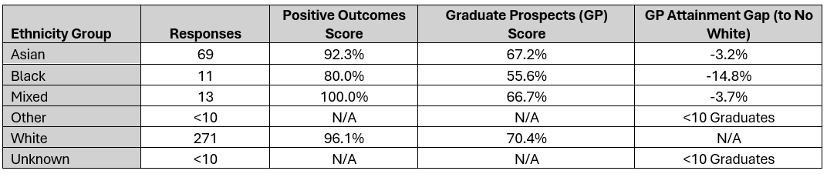
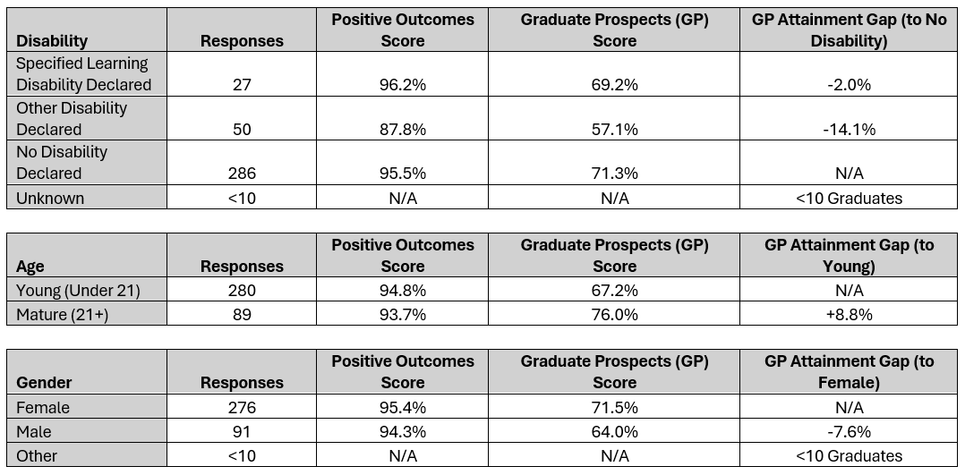
- Graduate Prospects (GP) Score = Students in highly-skilled employment or further education

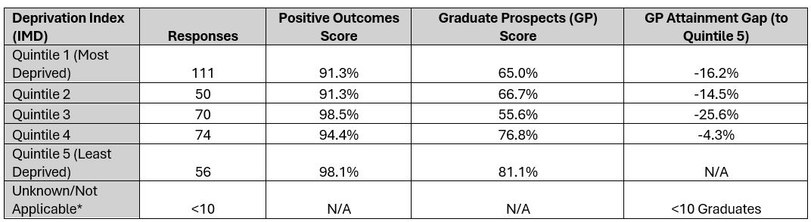
*e.g. overseas students

11.4.2 Graduate Outcomes – Postgraduate
- Positive Outcome Score = Students in any employment or further education
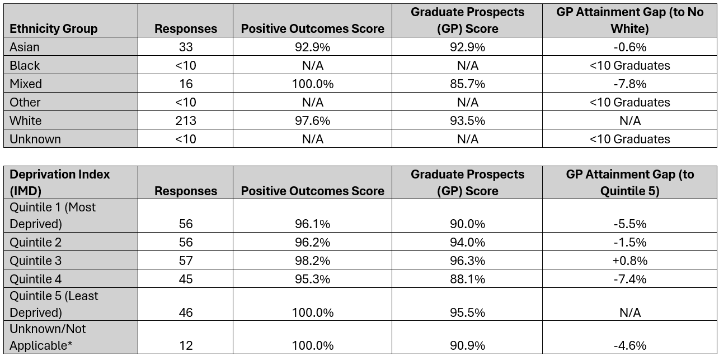
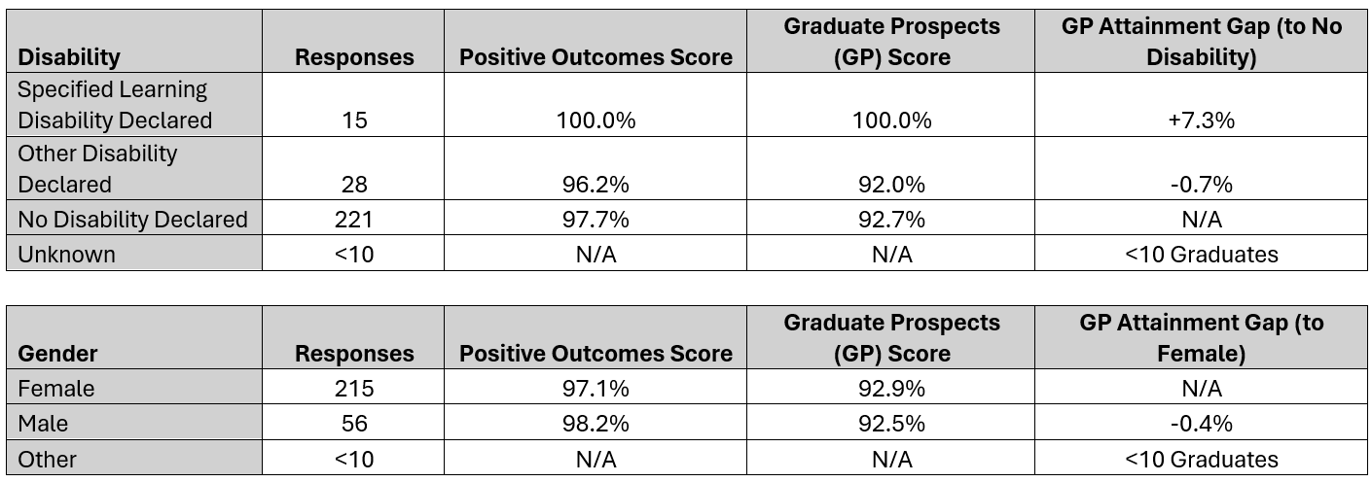
- Graduate Prospects (GP) Score = Students in highly-skilled employment or further education
Graduate outcome monitoring supports the University in identifying patterns in graduate progression and informing institutional enhancement activity.

12. Harassment, Complaints and Conduct
The University maintains policies and reporting mechanisms to address discrimination, harassment and victimisation. Formal reporting routes are available for colleagues and students to raise concerns relating to harassment, complaints and misconduct.

12.1 Student Complaints, Conduct and Casework

12.1.1 Student Reporting Procedures
Leeds Trinity University maintains clear procedures for addressing allegations of non-academic misconduct involving students. These procedures form part of the University’s wider framework for maintaining a safe, respectful and inclusive learning environment.
The Student Conduct Procedure provides the process through which allegations of non-academic misconduct are investigated and addressed. This procedure operates alongside the Student Code of Conduct and Student Conduct Policy and applies to all registered students at the University.
Under the procedure, reports of potential misconduct are reviewed by the Student Casework Team, who determine the appropriate route for investigation. Cases may be resolved through informal resolution where appropriate, or progressed to a formal investigation where the seriousness or repetition of the behaviour requires further action.
Following investigation, cases are categorised according to severity:
- Level 1 – Minor misconduct, typically addressed through warnings or educational outcomes.
- Level 2 – Moderate misconduct, considered by a Student Conduct Panel.
- Level 3 – Serious misconduct, also considered by a Student Conduct Panel and potentially resulting in significant sanctions.

12.1.2 Misconduct Case Volumes
During the reporting period, the University recorded:
- 72 students involved in non-academic misconduct cases
- 50 non-academic misconduct cases
Further analysis of cases is summarised below:
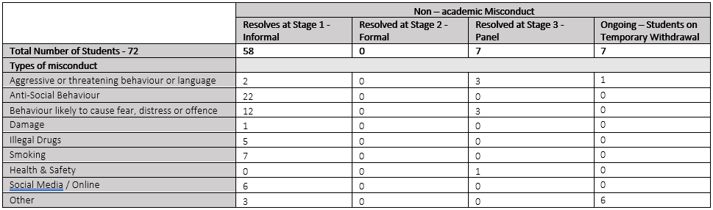
- Table A: Total number of cases by severity level (Level 1, Level 2, Level 3)

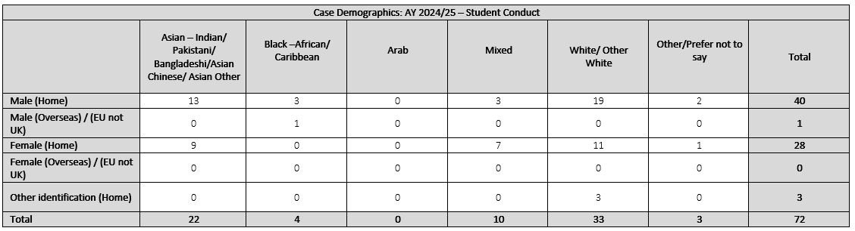
- Table B: Demographic profile of students involved in cases
- Table C: Non-academic misconduct cases involving students who have disclosed a disability
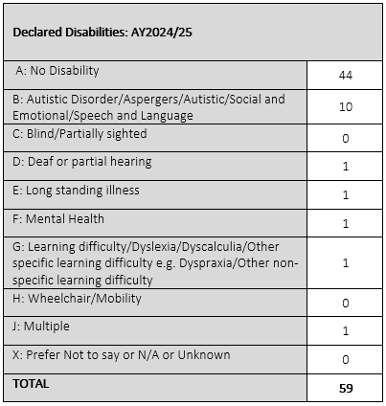

12.1.3 Fitness to Practise Cases
Students enrolled on programmes leading to professional registration with a Professional, Statutory or Regulatory Body (PSRB) may be considered under the University’s Fitness to Practise Procedure where concerns arise regarding professional conduct, competence or capability.
The Fitness to Practise Procedure ensures that concerns are addressed through a structured process that is fair, transparent and evidence-based. Concerns may relate to conduct, competence or health issues that could affect a student’s suitability for professional practice.
The procedure includes the following stages:
- Initial review and informal resolution where appropriate
- Formal investigation
- Consideration by a Fitness to Practise Panel
- Appeals where applicable
This framework ensures that students are treated fairly while also maintaining the professional standards required for regulated professions.
During the reporting period, the University recorded:
- 18 Fitness to Practise cases
Further analysis of cases involving students who have disclosed a disability is provided in the tables below:
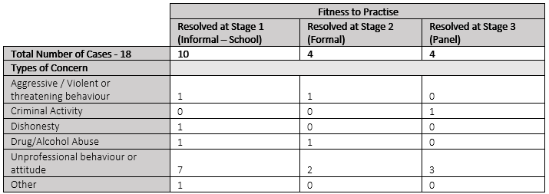
- Table D: Fitness to Practise cases by disability disclosure

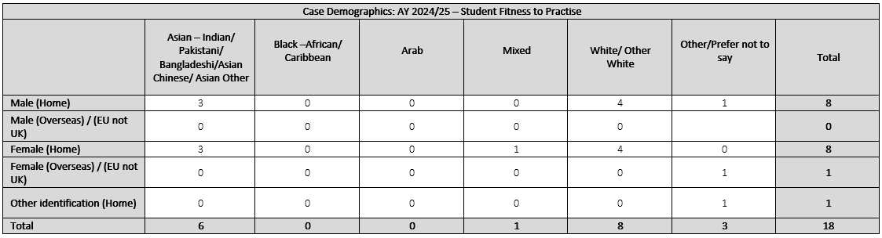
- Table E: Demographic profile of students involved in Fitness to Practice cases

12.1.4 Fitness to Study
Where concerns arise regarding a student’s ability to continue their studies safely due to ill health, the University may consider the case under the Fitness to Study Procedure.
This procedure allows the University to take proportionate action where there is evidence that a student’s continued participation in University life may pose a risk to their own wellbeing or to others. Decisions are made through the Student Conduct Panel and may include support measures, suspension, or other protective actions where necessary.
The process emphasises:
- consideration of reasonable adjustments
- implementation of support measures where appropriate
- balancing the interests of the individual student and the wider University community.

12.1.5 Student Complaints
Leeds Trinity University maintains a formal Student Complaints Policy and Procedure to ensure that concerns raised by students are addressed in a fair, transparent and timely manner. A complaint is defined as an expression of dissatisfaction by one or more students about the University’s action or lack of action, or about the standard of service provided by or on behalf of the University.
Students may raise complaints relating to areas such as academic provision, University services, facilities, the behaviour or treatment by a member of staff, or the failure to follow an appropriate administrative or academic process.
The complaints process operates through a three-stage framework consisting of early or local resolution, formal complaint investigation, and review of the complaint outcome. Where a complaint cannot be resolved through the University’s internal procedures, students may request an independent external review by the Office of the Independent Adjudicator (OIA).
During the reporting period, the University recorded:
- 26 formal student complaints.
Demographic data relating to protected characteristics is not currently collected as part of the complaints reporting process. Where complaints raise concerns relating to discrimination, harassment or other conduct matters, these may be considered under relevant University procedures and policies.

12.2 Colleague Complaints and Misconduct

12.2.1 Colleague Reporting Procedures
Leeds Trinity University maintains policies and reporting mechanisms to address concerns relating to bullying, harassment, discrimination and victimisation involving colleagues. These processes support the University’s commitment to providing a safe, respectful and inclusive working environment.
The University’s Dignity at Work and Study Policy sets out the standards of behaviour expected of colleagues and outlines procedures for addressing concerns relating to harassment, bullying or victimisation. Harassment is defined as unwanted conduct which violates a person’s dignity or creates an intimidating, hostile, degrading or offensive environment, including where conduct is related to a protected characteristic under the Equality Act 2010.
The Bullying, Harassment and Sexual Misconduct Policy provides a framework for preventing inappropriate behaviour and responding to incidents if they occur. The policy applies to all employees and workers of the University and sets out clear processes for reporting concerns and resolving complaints.
Colleagues are encouraged to report concerns at the earliest opportunity. Issues may be addressed through informal resolution where appropriate, or through formal procedures where the nature or seriousness of the concern requires formal investigation. Formal complaints may be progressed through the University’s grievance or disciplinary procedures where there is evidence that institutional policies or expected standards of behaviour may have been breached.
The University provides multiple routes through which colleagues can report concerns, including direct reporting to the People and Culture team and the use of an online reporting tool. Reports may also be made anonymously through the reporting system. All complaints are treated sensitively and investigated through appropriate procedures.

12.2.2 Complaint Volumes
The University monitors formal complaints raised by colleagues in order to identify potential trends and to ensure that workplace concerns are addressed appropriately. Complaints relating to bullying, harassment, discrimination or victimisation are managed through established procedures and are recorded through the University’s centralised case management processes.
Monitoring complaint volumes forms part of the University’s broader approach to promoting a respectful and inclusive working environment. Analysis of these cases supports the identification of any emerging patterns or areas requiring further attention and informs ongoing review of institutional policies and procedures.
During the reporting period, a small number of formal complaints were raised by colleagues. Due to the low number of cases recorded, specific figures are not reported in order to protect colleague confidentiality.
The complaints recorded during the reporting period related to a range of workplace concerns, including bullying, gender discrimination, race discrimination and religion or belief discrimination, as well as other general workplace grievances. In each category, the number of complaints recorded was below ten.
The majority of concerns raised during the reporting period were resolved through informal processes, with a small number progressing through formal procedures. In a limited number of cases, complaints were not upheld following review, and no cases were formally upheld during the reporting period.
Equality monitoring information associated with complaints indicates that concerns were raised by colleagues across a range of demographic groups. Given the small number of cases, detailed breakdowns by protected characteristic are not published in order to protect the confidentiality of those involved.
The University will continue to monitor employee relations cases and reporting patterns to ensure that concerns are addressed appropriately and that workplace policies and procedures remain effective in supporting a respectful and inclusive working environment.

13. Accessibility and Publication
This document is published on the University website.
Alternative formats (including large print or accessible formats) are available on request via hr@leedstrinity.ac.uk
The report can be found at: Equality, Diversity and Inclusion - About - Leeds Trinity University

14. Approval and Governance
This report has been considered through the University’s governance framework.
- Oversight: UEG
- Executive responsibility: University Executive
[INSERT DATE OF FINAL APPROVAL]

