DEGREE OUTCOMES STATEMENT

A summary of degree outcomes for all Leeds Trinity undergraduate (UG) provision is contained in the tables below.

Institution Summary Campus-Based Non-Apprenticeship (Excluding Apprenticeships & Partnerships)

The data in the table below reflects a fluctuating profile of ‘good’ (2:1 and 1st) degrees, with the biggest decline between 20/21 and 21/22 (-12.5%). 24/25 shows an increase on 23/24 (+3.3%).

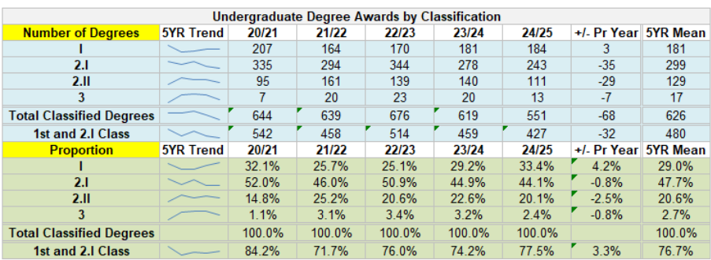

Analysis

- 24/25 shows a 3.3% increase in the proportion of ‘good’ degree awards to 77.5%, the highest level since 20/21.
- This is the result of an improving trend of 1st class degree awards, a (+4.2%) increase from 23/24 to a 5-year high (33.4%).
- The 2:1 degree award has seen a marginal decline (-0.8%) in 24/25 from 23/24.
- A reduction in 2:2 degree awards is noted (-2.5%) in 24/25, with a return to 22/23 figures (20.6%)
- A third year of reduction is observed in 3rd class degree awards (-0.8%) in 24/25.

Institution Summary Campus-Based Including Apprenticeships (Excluding Partnerships)
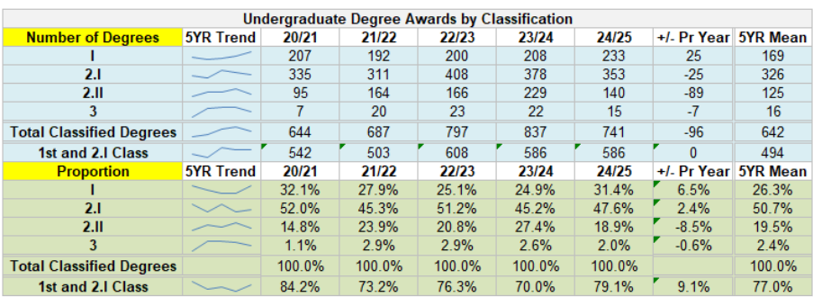
Analysis

- 24/25 shows a 9.1% increase in the proportion of ‘good’ degree awards for on-campus and Apprenticeships to 79.1%, the highest level since 20/21.
- The primary reason is an increased profile of 1st class degree awards from 24.9% (23/24) to 31.4% (24/25), the highest in four years, marking a return towards 20/21 figures
- 2:1 degree awards increase 2.4% in the latest year to 47.6%, although it is noted that this remains lower than 20/21 (52.0%).
- The majority of the improvement in ‘good’ degree awards comes from a reduction in 2:2 awards, down 8.5% in 24/25 compared to the previous year.
- The proportion of 3rd class degree awards made remains low at 2.0%.

Institution Summary Overall (Including Apprenticeships & Partnerships)
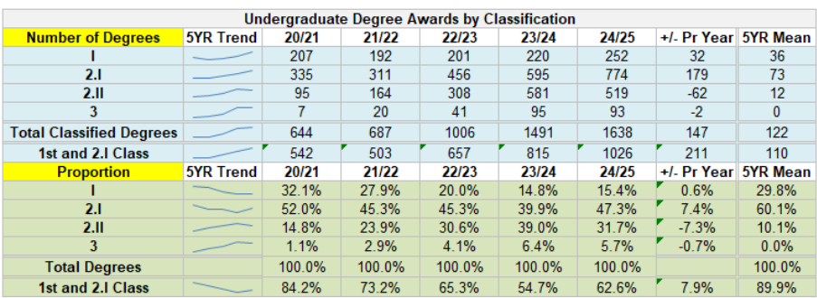
Analysis

- 24/25 shows a 7.9% increase in the proportion of ‘good’ degree awards for all provision to 62.6%, this reverses a declining year on year trend over the previous years.
- The proportion of 1st class degree awards increased slightly compared to 23/24 to 15.4%; however this remains well below earlier years.
- An increase in 2:1 degree awards is observed in 24/25 (+7.4%), the highest level since 20/21 (52.0%).
- The majority of the improvement in ‘good’ degree awards comes from a reduction in 2:2 awards, down 7.3% in 24/25 compared to the previous year.
- 3rd class degree awards had been increasing year on year over the 5-year period, until 24/25, where a small reduction is noted (-0.7%).

Overall Summary

- Over the 5-year analysis period, the data across all tables shows a general decline in profile of ‘good’ degrees (2:1 and 1st) until 24/25 where improvements of awarding 1st and 2:1 degrees are observed. This pattern of improvement includes UG on campus, Apprenticeships and partner provision. The improvement is driven by an increase in the proportion of 2:1 degree awards, up 7.4% to 47.3%.

- On average, within the analysis period, a circa 10% decline is seen each year in awarding of ‘good’ degrees, until 24/25, where an improvement (+7.9%) to 62.6% is seen.

- In 24/25, UG on-campus sees a 4.2% increase in 1st class degree awards. When you include Apprenticeships, this increases to 6.5%. Partner provision reduces the increase in 1st class degree awards to 0.6%.

- In 24/25, students studying with partners, achieve lower award classifications. UG on –campus and Apprenticeship award classifications are 18.9% with 2:2 and 2.0% achieving 3rd class degrees. When partner data is included, this increases 2:2 degree awards to 31.7% and 3rd class degrees to 5.7%.

- 20/21 outcomes were high due to the impact of regulations at that time (No Detriment Policy).

- However, despite improvements, the data still reports the University behind the national picture. OfS reported nationally in 22/23, a downward trend in ‘good’ degrees, with 77.6% per cent of students receiving a first or upper second-class degree (-12.3%, LTU) compared with 80.7% per cent in 21/22 (-7.5%, LTU)

- Assessment and Marking Practices
Assessments are set to enable students to evidence they have met the learning outcomes associated with their programme of study. These are set according to the level of the programme award (i.e. Level 3 Foundation Year; Level 4–6 Undergraduate and Level 7 Masters) which are in turn aligned to the threshold standard for the level described in the Framework for Higher Education Qualifications. In instances where programmes have Professional Statutory Regulatory Body (PSRBs) accreditation or part accreditation, some assessment requirements may be set by those bodies.

To support academic colleagues in applying consistent marking practices, a University Handbook on Assessment Practice - Guide for Staff describes all the processes associated with assessment practice, including use of marking criteria, standardisation, internal moderation, double marking, sampling and verification, and external moderation by external examiners. External Examiners are appointed for programmes, including those delivered by collaborative partners, through a process which considers the suitability of the nominee in terms of both relevant subject coverage and experience (with mentors assigned as necessary) and consideration of any inadvertent reciprocity either between individuals or between Leeds Trinity University (LTU) and the home institution of the external. Module assessment outcomes are submitted to Assessment Panels, which include External Examiners; recommendations for progression and awards are submitted to Progression and Award Boards. These Boards also have oversight of the assessment outcomes from collaborative partners.

If students believe there are reasons why they may not be able to perform to the best of their ability, there are two processes available to them to ensure these are considered and taken into account if deemed to be justifiable. These include Mitigating Circumstances Policy and Procedure and an Academic Appeals Policy and Procedure. The former enables students to submit for consideration of mitigating circumstances prior to submission of assessment and the latter for reconsideration of outcomes on certain criteria subsequent to the publication of assessment outcomes. These processes are conducted by professional and academic staff who are trained in the requirements of the process; records are maintained and provide an archive of case law, which supports consistency in application, and, in the case of Academic Appeals, an annual report is produced, which analyses appeals by School and student characteristics and makes recommendations for any change or enhancement to the process.

The use of External Examiners, and their annual reports; the Procedural External Reviewer (who oversees the operation of Progression and Award Boards); the inclusion of progression and award data in the Institutional Annual Quality Report (IAQR) and other reporting – are all mechanisms which provide evidence on which the University can judge the effectiveness of its assessment and marking practices. An institutional overview report is produced which provides a thematic analysis of all external examiner reports. This is presented on an annual basis to the Academic Quality and Standards Committee.

In 2018/19, the University changed its marking protocols from predominantly granular numeric marking to a categorical marking protocol, with Foundation Year programmes adopting this in September 2022. Staff were supported in the application of the new marking arrangements through staff development and workshops and guidance for its application is described in the Handbook on Assessment Practice referred to above.

- Academic Governance
Progression and Award Boards have delegated authority from the Academic Board to approve progression and award decisions on recommendations arising from Assessment Panels, including those conducted by the University’s collaborative partnerships.

Programmes are designed in alignment with sector level reference points such as the Framework for Higher Education Qualifications (FHEQ) and subject benchmark statements; these set the national points of reference for higher education providers and their external examiners when setting and assessing academic standards.
- At the point of assessment design, programmes teams are required to demonstrate constructive alignment across the breadth of a programme, and undergraduate programmes should demonstrate clear incremental gain, by level, to ensure increasing intellectual requirement at each level of study.
- Assessment criteria are designed at module level, and student performance in assessment should be measured against criteria (criterion-based assessment), not in relation to the performance of other students (norm-referenced assessment).
- All modules should have well-designed criteria and/or rubrics to ensure assessment requirements and expectations need to be clear and explicit for both students and markers. These should be reviewed during the academic delivery sign off process.

A series of processes assure marking practice. These include:
- A requirement for all module teams to provide a session where the assessment brief is unpacked with students, to scaffold their assessment literacy and understanding of the assessment task, what is required and how it will be assessed.
- All programme teams are expected to adopt an agreed, consistent approach to assessment of student work.
- All marking teams are required to undertake a standardisation activity prior to marking the full cohort to ensure consistency of marking, grading, quick marks and in-text comments against the assessment criteria.
- Students should expect their assessment and grade to be returned 15 working days after submission.
- All students should receive developmental feedback and feed forward to support their success in future assessment and to provide clarity on the grade awarded.
- A sample of assessments from across grade bands and markers are internally and externally moderated to ensure effective marking practices.

In 2023/24, Part A of the Institutional Annual Quality Report (IAQR) highlighted features of change, good practice or recommendations arising from the implementation of the University’s usual processes of quality assurance (which are aligned to the UK Quality Code for England Core Practices for standards and quality and are designed to ensure compliance with the OfS B Conditions of Registration for Quality and Standards) undertaken during the preceding academic year. Part B of the IAQR considers 5-yearly trend data of student progression and retention by level and student characteristic and as stated previously, looks at degree outcome data.

Moving forward, and as part of the review of 24-25, the governing body will be provided with thematic triannual reports on Quality and Standards across the University. These will still contain the features of change, areas of good practice and areas of action and recommendations arising from quality processes in line with the UK Quality Code for England (2024) Core Practices for standards and quality and are designed to ensure compliance with the OfS B Conditions of Registration for Quality and Standards. Alongside this, regular reporting against the progress of the actions identified within the Institutional Quality Action Plan will be provided.

- Classification Algorithms
The University has a degree classification algorithm that uses three methods of calculation, with the best outcome determining the classification awarded. The three methods start with an arithmetic mean of marks for the 240 credits studied at Level 5 and 6; an arithmetic mean mark weighted in ratio 2:1 in favour of Level 6 and finally a mark profile (classification) across Level 5 and 6 weighted in ratio 2:1 in favour of Level 6. The number of credits at each classification is summed until 50% of credits (180) have been accounted for. The Honours classification will then be classification at which the process of summation ends.

These three methods of calculation support the rationale that performance may:

- show a strong performance over all years of the programme (calculation i);
- show performance more strongly in the final year as the student becomes able to make connections across the breadth of the programme (calculation ii and iii).

The use of both average mark and profile allows for the recognition of both consistent performance across the programme (profile) and exceptional areas of strength. Our procedures and regulations make no allowance for any special consideration to be given to borderline marks.

Algorithms are described in the Taught Programme Academic Regulations (TPAR), which are published in the myLTU app (Essential Information) as the prime location for student information and on the University’s website. Module and Personal Tutors support students in understanding how their award outcome will be calculated and a ‘Degree Calculator’ is available to enable students to input known marks which then calculates their potential outcome - enabling students to aim for the best possible classification. Prior to the final classification of award, which is confirmed by the Progression and Award Boards, there are mechanisms which allow for resits of failed modules. In these cases, marks are capped at the pass mark (40% for undergraduate programmes).

The University had a review of its academic regulations in 2023/24 which was undertaken by an external consultant. The appointment process was by tender with criteria designed to establish suitability to undertake the task with particular reference to knowledge of sector practice and academic standards informed by the FHEQ, QAA [Subject] Benchmark Standards and the QAA Quality Code. This can provide assurance to the University that its regulations are in line with sector norms. This is also endorsed by External Examiners who are asked to confirm comparability of standards with the sector.

We are confident that our algorithm is in alignment with sector practice, as set out in the UKSCQA document and the UUK/GuildHE report on the configuration of degree algorithms. However, the University is committed to reviewing algorithm design to ensure it remains in alignment with sector standards and would adhere to the UKSCQA Principles for Effective Degree Algorithm Design when carrying out any review. With that in mind, and ahead of 26/27 publication, the University plans to engage with an external review of its award algorithm in 25/26.

- Teaching Practices and Learning Resources
We want all our students to succeed – both academically and personally – so we have introduced a range of initiatives and developed strategies which support student success and positive outcomes for all students.

We believe that several enhancements at LTU are likely to have had a positive effect in improving student academic performance and outcomes. These include:

- The development of Principles for Learning and Teaching Delivery to enhance and further develop LTU’s innovative blended learning model based on ‘Pre, Live, Post’ activities to support independent and flexible learning and build the digital capabilities of students. This includes extending the model from Pre, Live, Post to: Pre: Orientation & exploration, Live: Practice & Production and Post: Integration & reflection.

In addition, to ensure student success, effective assessment practice and taking an evidence-informed view of assessment good practice, LTU have conducted a review of assessment during academic year 2023/24 and impact has led to:

- Implementing the agreed short and long-term recommendations in the Inclusive Assessment and Assessment for Social Justice Paper (led by the Curriculum for Social Justice) commencing with developing inclusive assessment principles and guidance to inform review and design processes.
- Standardisation of (and rationalising) the overall number of summative assessments components per 30-credit module. E.g. stipulating a maximum number of two summative assessment components per module (plus a potential additional assessment component for programmes overseen by PSRBs).
- Standardisation of word count (or equivalent) of summative assessments per 30-credit module, per level.
- Offering students greater partnership in decision making about assessment through co-creation approaches.
- A review of module learning outcomes and assessment to ensure constructive alignment.

- Governing Body
The Governing Body will revisit the actions identified within the Degree Outcomes Statement and their progress through the Institutional Action Plan triannually.

APPENDIX A – DATA EXTRACT FROM STUDENT OUTCOMES UPDATE – 23rd OCT 2025

Degree Award Outcomes by Graduation Year
In order to ensure that the awards data is not skewed by poor pass/progression rates prior to graduation, the following data shows all awards made in each graduation year.
Campus-Based Undergraduate Degrees
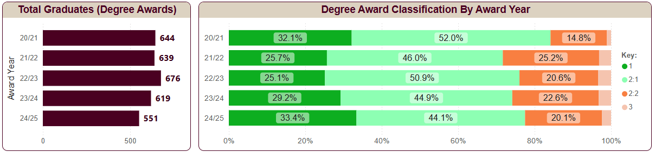
Partnership Undergraduate Degrees (First Cohort of Graduates in 22/23)
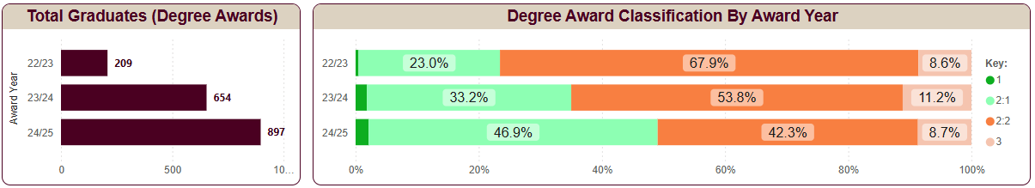
Campus Based PGCE
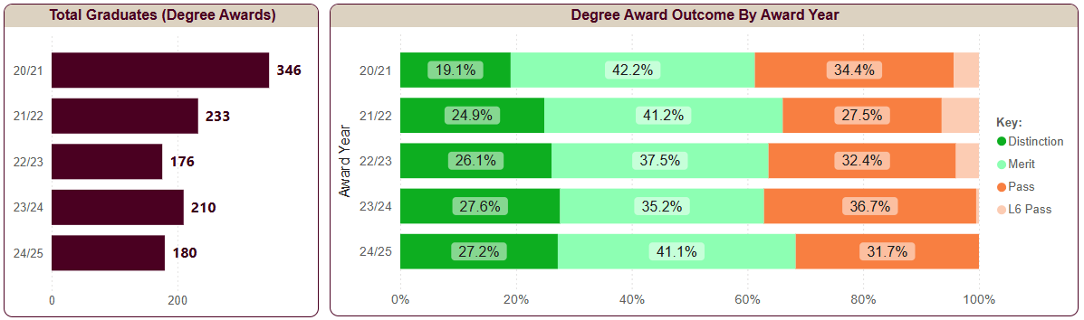
Campus Based PG Masters
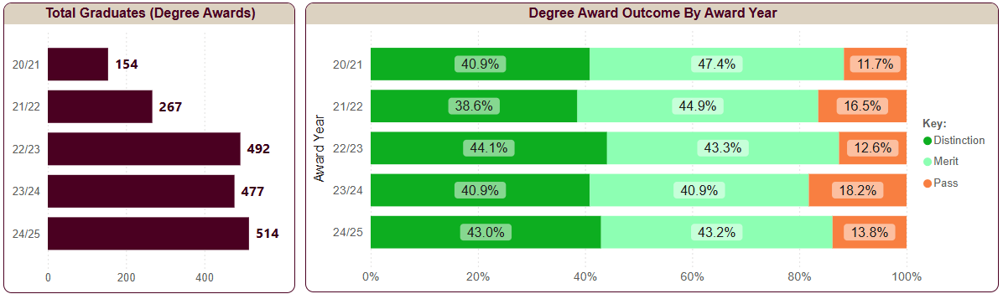

Partnership PG Masters
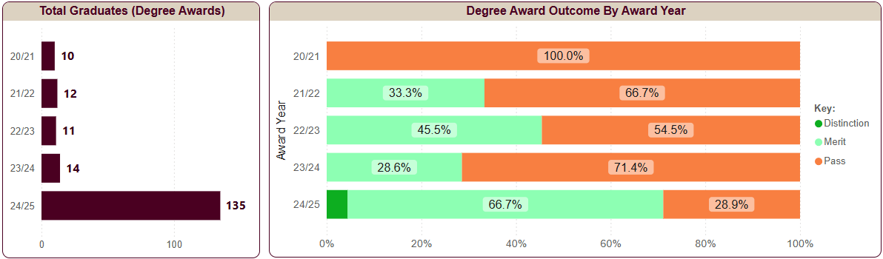
Undergraduate 1st/2:1 Award Outcomes by Graduation Year
The number of LTU graduates is increasing year on year. This is due to partnership students reaching graduation. The overall proportion of 1st or 2:1 classification degree awards has improved 7.9% to 62.6% of 1,638 graduates, driven by an increase in 1st/2:1 awards across all types of provision. However, this does remain substantially lower than 20/21 and 21/22.
Award classification by programme type and graduation year
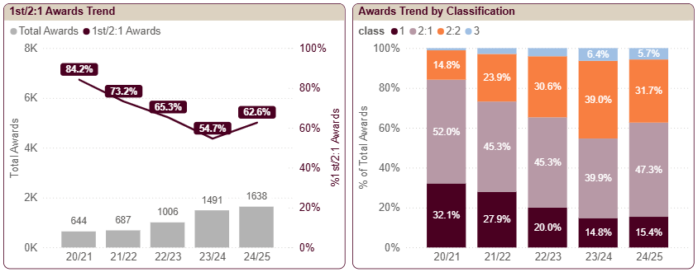
Partnership students receive a much lower proportion of 1st/2:1 awards compared to Campus-Based Provision (49.1% of 897 graduates in 24/25). However, this does represent a year-on-year improvement since partner students first reached graduation in 22/23.

Undergraduate degree 1st/2:1 awards by provision type and graduation year
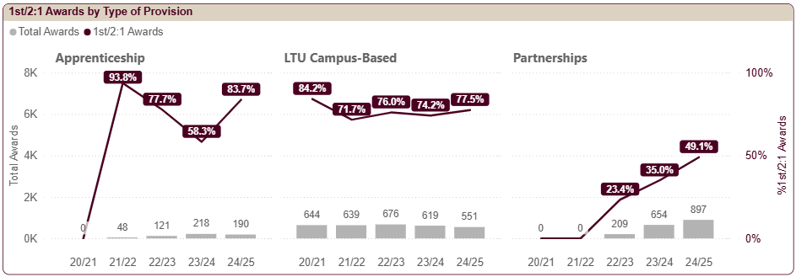
Campus-based provision has seen the gap in outcomes narrow between students that entered at foundation year (4-year programme) and students that entered at level 4 (3-year programme). From the first cohort of Foundation Year graduates only 52.6% received a 1st/2:1, this has risen year on year to 74.8% in 24/25, just 3.6% lower than graduates who entered at level 4.

Undergraduate degree 1st/2:1 awards by entry point (campus based excl. apprenticeships)
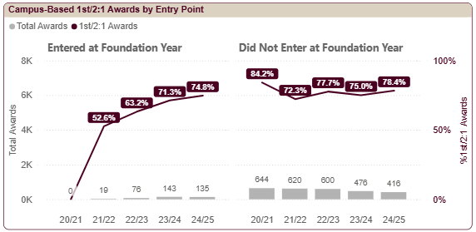
The proportion of awards made with classification 1st or 2:1 varies between Campus-Based schools. Sport and Wellbeing consistently has a low proportion of 1st/2:1 awards compared to other schools; in 24/25 only 58.5% of graduates got these top grades. However, this was an 11.8% increase from the previous year. Law (68.0%) and Digital & Screen Media (73.4%) also had lower than the institution average in 24/25.
Undergraduate degree 1st/2:1 award by School and graduation year (campus based including apprenticeships)
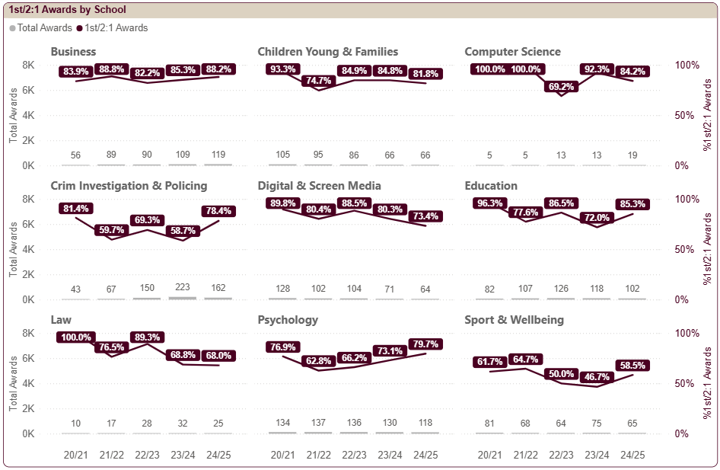
The 1st/2:1 awards remain lower for partner graduates compared to LTU. Only 49.1% of 897 partnership graduates were awarded a 1st/2:1. Although, there has been continuous year-on-year improvement. The 1st/2:1 awards were very low in LDT Business (2.5% of 243 graduates). Also, SSS Business is low but improving (36.5% of 126 graduates).

Undergraduate degree 1st/2:1 award by School and graduation year (partnerships only)
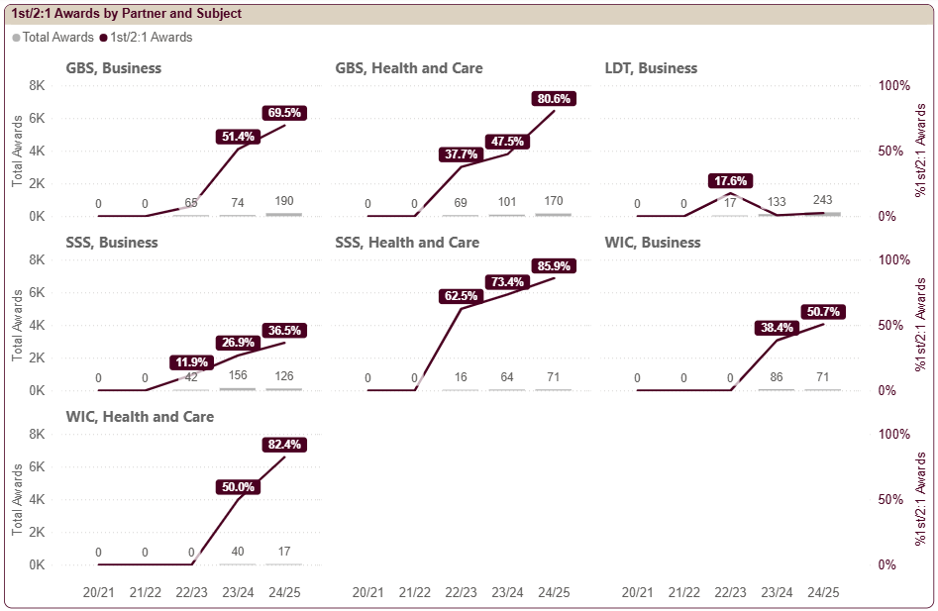

Undergraduate Awarding Gaps
Attainment gaps show the difference in performance of students with paired characteristics e.g. male compared female students. Attainment gaps are complex since the mixture of students in each type of provision can affect the overall Leeds Trinity attainment gap data.

There has been a sharp increase in the proportion of 1st/2:1 awards to BAME students (improvement of 26.6% to 62.6% of 704 graduates), this has virtually closed the ethnicity awarding gap for the first time in five years (0.2% gap).

All non-white ethnicities achieved a higher proportion of 1st/2:1 awards than white graduates except for “Other” which has a relatively small number of graduates. This narrowing of the institution award gap by ethnicity is driven by a reverse awarding gap amongst partner graduates (E.g. white partner students achieving weak outcomes). In addition, there have also been reductions in the campus-based ethnicity awarding gaps.

There are substantial awarding gaps by Age, Entry Point and Deprivation. However, these are skewed by partner graduates having weaker outcomes, age profile and foundation year entrants are typically from deprived areas. However, within each type of provision these awarding gaps are smaller.

There are awarding gaps evident for students that enter with BTEC qualifications and those with lower UCAS tariff. Indeed, these students are less likely to receive 1st/2:1 awards.

Undergraduate degree 1st/2:1 awarding gap by graduation year (All Provision)
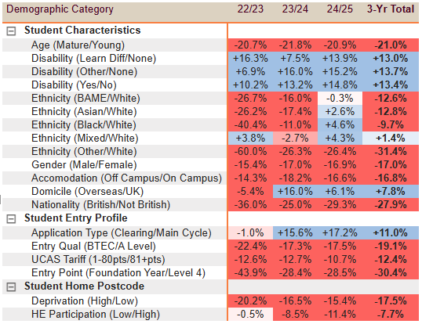

Undergraduate degree 1st/2:1 awarding gap by graduation year and type of provision
